SOFT562 Software Development and Databases Coursework Assignment Report

Course: Master of Science Data Science and Business Analytics (MDSD5 2001A, MDSE2 2001A)

Module leader: William Ku Chee Chiang

Author: Cassandria Goh

Contents

Initial ERD 4

Results of Normalization 4

Unnormalized form 4

First Normal Form 5

Second Normal Form 6

Third Normal Form 6

Final ERD 7

SQL Query Statements to Create Table 7

Populating the Database 10

C# Interface 10

Login screen 10

The code behind the Login screen 10

The user interface 13

Users form 13

The code behind the Users form 13

The user interface 18

Create 18

Read 19

Update 29

Delete 29

Extra forms 29

Messages form 30

The code behind the Messages form 30

The user interface 32

Uninwork form 34

The code behind uninwork form 34

The user interface 36

Test plan 36

SQL Table Creation 37

Verifying that the tables with appropriate data types are created 37

Validating that the SQL queries produce appropriate tables and relationships 39

Populating the Database 39

Validating that data can be imported correctly 39

Verifying that data import with INSERT INTO statements is correct and accurate 40

Users data 40

Friends data 41

Universities data 42

Workplaces data 43

Messages data 44

Verifying that the entire data set has been imported properly 45

Users data 45

Friends data 46

Universities data 47

Workplaces data 47

Messages data 48

C# Interface 49

Users form 49

Validation of data entry into the Users form 49

Verify that create works 50

Verify that read works 52

View all users button 52

Combo box 52

UserID text box 53

Look for my ID button 54

Verify that update works 55

Verify that delete works 56

Conclusion 59

Areas for Improvement in Future Projects 59

Normalization 59

User Credentials 59

Messages and Uninwork forms 60

References 61

Appendix 62

Login Screen Error Messages 62

Messages form 63

Data validation 63

Uninwork form 64

Data verification 64

Data validation 66

# Initial ERD

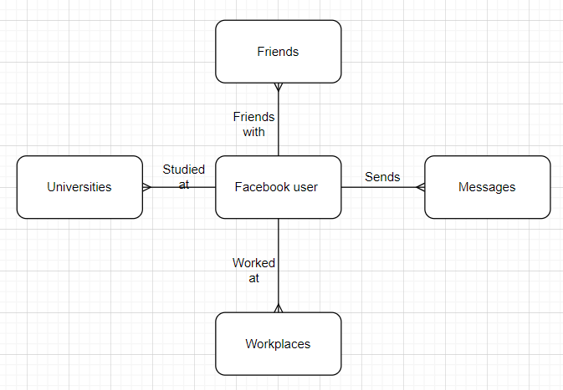

Figure 1: Initial ERD based on Facebook user sample provided

A Facebook user will have multiple attributes detailing the user information such as UserID, name, location, gender, and relationship status. A Facebook user can have multiple friends, send multiple messages, attend multiple universities and work at multiple workplaces. Hence, there is a one-to-many relationship between a Facebook user and their friends, messages, universities and workplaces.

# Results of Normalization

## Unnormalized form

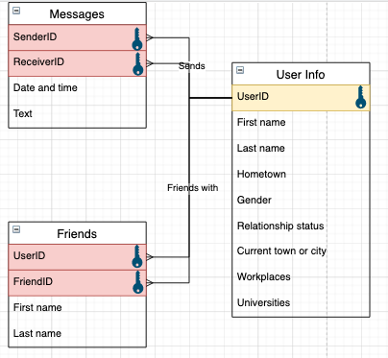

Figure 2: Unnormalized form (UNF)

The unnormalized form starts off with 3 tables: User Info, Friends and Messages. Where “User Info” contains details about a user including their workplaces and universities. “Messages” describes the messages exchanged between user with UserID of “SenderID” and another user with UserID of “ReceiverID”. Lastly, “Friends” details the friends that a particular user has.

Before proceeding with the normalized data structures, it should be noted that there are specific colours and labels that have been used for better illustration.

* Red highlight – foreign key
* Yellow highlight – key chosen from attributes to be a part of the primary key
* Key symbol – to illustrate which attributes/columns contribute to the primary key for the table

## First Normal Form

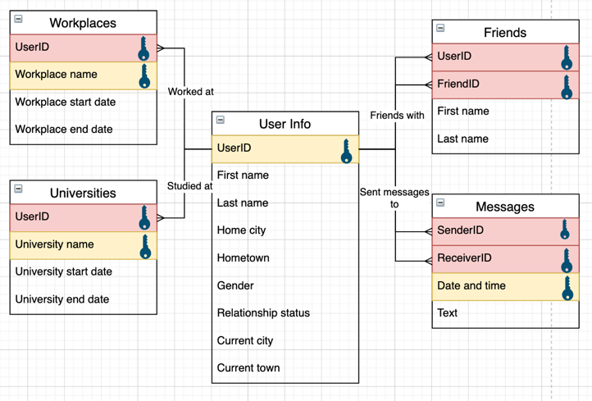

Figure 3: First normalized form (1NF)

In order to move from the unnormalized form into first normal form, the data was atomized and all repeating groups were separated into separate entities. Repetition is seen with the user’s universities and workplaces; therefore, these attributes were separated into other tables. The foreign keys (red highlights) stem from the original “User info” table and act as a composite key with the selected key (yellow highlight) in each group.

## Second Normal Form

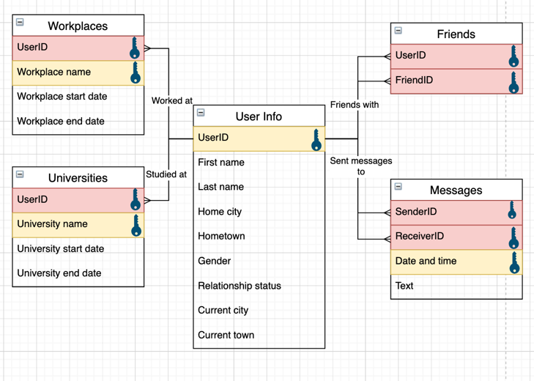

Figure 4: Second normalized form (2NF)

With first normal form achieved, now the tables with composite keys need to be checked for partial dependencies. If any of the entities within said tables are only reliant on part of the composite key, they need to be separated. Most of the tables contain attributes that rely on the entire composite key. The only table that does not adhere to the rules of second normal form is the “Friends” table as the first name and last name of the friend only relies on the “FriendID” key and does not rely on the “UserID” key. Although these attributes can be separated into another table, it will lead to duplication as this information is already available in the “User info” table, so these attributes would simply be removed from the “Friends” table.

## Third Normal Form

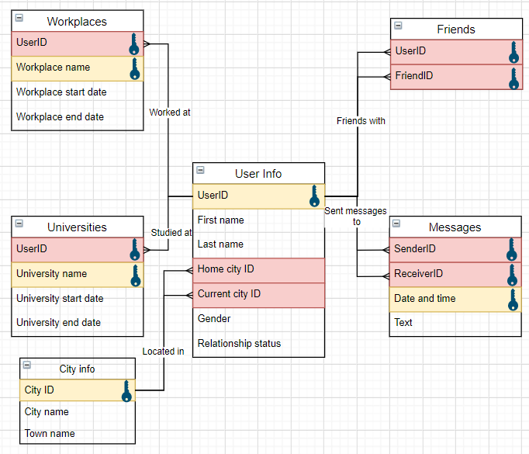

Figure 5: Third normalized form (3NF)

Once second normal form has been achieved, all table attributes have to be checked for transitive dependencies. If any attribute within the tables is dependent on other non-key attributes within the same table, it needs to be separated. Within the current ERD, most of the tables are already in third normal form. The only table that needs amendment is the “User info” table as the “Hometown” and the “Current town” attributes are reliant on the “Home city” and “Current city” attributes, respectively. To solve this, another table titled “City info” is created to contain the relationship between “City name” and “Town name”. Each relationship within the “City info” table is then given a “City ID” which is the primary key of the “City info” table and the foreign key within the “User info” table.

# Final ERD

After following the rules to get data from unnormalized to third normal form, the final ERD is derived:

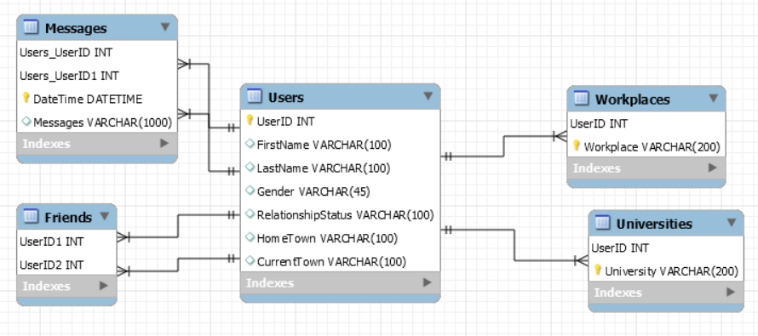

Figure 6: Final ERD illustrated in SQL Workbench

Upon closer inspection, this ERD lacks the “City info” table. This is due to the datasets provided only containing town names, no city names and the assignment does not require any querying of the city names. Therefore, factoring in the datasets that were provided, the “Users” table is a subset of what was originally illustrated above in the “Third Normal Form” section.

# SQL Query Statements to Create Table

The following are SQL Query statements that can be used to create the Facebook schema, “fb” and the tables within the schema: “users”, “messages”, “friends”, “universities”, and “workplaces” if they do not already exist.

-- -----------------------------------------------------

-- Schema fb created if it doesn’t already exist. If it exists, this code will be skipped and next row will be executed

-- -----------------------------------------------------

CREATE SCHEMA IF NOT EXISTS `fb` DEFAULT CHARACTER SET utf8mb4 COLLATE utf8mb4_0900_ai_ci ;

USE `fb` ;

-- -----------------------------------------------------

-- Table `fb`.`users` created if it doesn’t already exist with UserID, FirstName, LastName, Gender,

-- RelationshipStatus, HomeTown, CurrentTown attributes created and set to appropriate data types and keys

-- -----------------------------------------------------

CREATE TABLE IF NOT EXISTS `fb`.`users` (

`UserID` INT NOT NULL AUTO_INCREMENT,

`FirstName` VARCHAR(500) NULL DEFAULT NULL,

`LastName` VARCHAR(500) NULL DEFAULT NULL,

`Gender` VARCHAR(45) NULL DEFAULT NULL,

`RelationshipStatus` VARCHAR(500) NULL DEFAULT NULL,

`HomeTown` VARCHAR(500) NULL DEFAULT NULL,

`CurrentTown` VARCHAR(500) NULL DEFAULT NULL,

PRIMARY KEY (`UserID`))

ENGINE = InnoDB

AUTO_INCREMENT = 63750

DEFAULT CHARACTER SET = utf8mb4

COLLATE = utf8mb4_0900_ai_ci;

-- -----------------------------------------------------

-- Table `fb`.`friends` created if it doesn’t already exist with UserID1 and UserID2 attributes created and set to

-- appropriate data types and keys

-- -----------------------------------------------------

CREATE TABLE IF NOT EXISTS `fb`.`friends` (

`UserID1` INT NOT NULL,

`UserID2` INT NOT NULL,

PRIMARY KEY (`UserID1`, `UserID2`),

INDEX `fk_table1_Users2_idx` (`UserID2` ASC) VISIBLE,

CONSTRAINT `fk_table1_Users1`

FOREIGN KEY (`UserID1`)

REFERENCES `fb`.`users` (`UserID`),

CONSTRAINT `fk_table1_Users2`

FOREIGN KEY (`UserID2`)

REFERENCES `fb`.`users` (`UserID`))

ENGINE = InnoDB

DEFAULT CHARACTER SET = utf8mb4

COLLATE = utf8mb4_0900_ai_ci;

-- -----------------------------------------------------

-- Table `fb`.`messages` created if it doesn’t already exist with Users_UserID, Users_UserID1, DateTime and

-- Messages attributes created and set to appropriate data types and keys

-- -----------------------------------------------------

CREATE TABLE IF NOT EXISTS `fb`.`messages` (

`Users_UserID` INT NOT NULL,

`Users_UserID1` INT NOT NULL,

`DateTime` DATETIME NOT NULL,

`Messages` VARCHAR(1000) NULL DEFAULT NULL,

PRIMARY KEY (`Users_UserID`, `Users_UserID1`, `DateTime`),

INDEX `fk_Messages_Users2_idx` (`Users_UserID1` ASC) VISIBLE,

CONSTRAINT `fk_Messages_Users1`

FOREIGN KEY (`Users_UserID`)

REFERENCES `fb`.`users` (`UserID`),

CONSTRAINT `fk_Messages_Users2`

FOREIGN KEY (`Users_UserID1`)

REFERENCES `fb`.`users` (`UserID`))

ENGINE = InnoDB

DEFAULT CHARACTER SET = utf8mb4

COLLATE = utf8mb4_0900_ai_ci;

-- -----------------------------------------------------

-- Table `fb`.`universities` created if it doesn’t already exist with UserID and University attributes created and set to

-- appropriate data types and keys

-- -----------------------------------------------------

CREATE TABLE IF NOT EXISTS `fb`.`universities` (

`UserID` INT NOT NULL,

`University` VARCHAR(200) NOT NULL,

PRIMARY KEY (`UserID`, `University`),

CONSTRAINT `fk_Universities_Users`

FOREIGN KEY (`UserID`)

REFERENCES `fb`.`users` (`UserID`))

ENGINE = InnoDB

DEFAULT CHARACTER SET = utf8mb4

COLLATE = utf8mb4_0900_ai_ci;

-- -----------------------------------------------------

-- Table `fb`.`workplaces` created if it doesn’t already exist with UserID and Workplace attributes created and set

-- to appropriate data types and keys

-- -----------------------------------------------------

CREATE TABLE IF NOT EXISTS `fb`.`workplaces` (

`UserID` INT NOT NULL,

`Workplace` VARCHAR(200) NOT NULL,

PRIMARY KEY (`UserID`, `Workplace`),

CONSTRAINT `fk_Workplaces_Users1`

FOREIGN KEY (`UserID`)

REFERENCES `fb`.`users` (`UserID`))

ENGINE = InnoDB

DEFAULT CHARACTER SET = utf8mb4

COLLATE = utf8mb4_0900_ai_ci;

# Populating the Database

In order to populate the database from MySQL Workbench, a folder with the SQL text files with INSERT INTO statements will be provided for each table. To populate the database, open each file in MySQL Workbench and run the file. Do note that it might take a while to load the data as some of these files are quite large.

# C# Interface

To watch a demo of the interface, please follow this link: [(117) SOFT562 Assignment Demo Cassandria Goh - YouTube](https://www.youtube.com/watch?v=TPcaGH3fLs4&feature=youtu.be)

## Login screen

### The code behind the Login screen

using System;

using System.Collections.Generic;

using System.ComponentModel;

using System.Data;

using System.Drawing;

using System.Linq;

using System.Text;

using System.Threading.Tasks;

using System.Windows.Forms;

using MySql.Data.MySqlClient;

namespace facebook

{

public partial class Login : Form

{

public static string connectionString;

public Login()

{

InitializeComponent();

}

public string ConnectString()

{

string connectionString = "SERVER=" + DBConnect.SERVER + ";" +

"DATABASE=" + DBConnect.DATABASE_NAME + ";" + "UID=" +

UsernameBox.Text + ";" + "PASSWORD=" +

PasswordBox.Text + ";" + "SslMode=" +

DBConnect.SslMode + ";";

return connectionString;

}

private void LoginButton_Click(object sender, EventArgs e)

{

// If no username is entered

if (UsernameBox.Text == "")

{

// And no password is entered, then missing username and password

if (PasswordBox.Text == "")

{

MessageBox.Show("Please enter a username and a password!");

}

// And password is entered, then only missing username

else

{

MessageBox.Show("Please enter a username!");

}

}

// If username is entered

else

{

// And no password is entered, then missing password

if (PasswordBox.Text == "")

{

MessageBox.Show("Please enter a password!");

}

// And password is entered, then all login credentials needed.

else

{

using (MySqlConnection connection = new MySqlConnection(ConnectString()))

{

try

{

connection.Open();

}

catch

{

MessageBox.Show("Invalid entry, please double check username and password");

}

}

if (!(CRUDCheck.Checked) & !(MessageCheck.Checked) & !(UniNWorkCheck.Checked))

{

MessageBox.Show("Please select a form to open!");

}

if (CRUDCheck.Checked)

{

using (MySqlConnection connection = new MySqlConnection(ConnectString()))

{

try

{

connectionString = ConnectString();

connection.Open();

var myForm = new Users();

myForm.Show();

}

catch

{

}

}

}

if (MessageCheck.Checked)

{

using (MySqlConnection connection = new MySqlConnection(ConnectString()))

{

try

{

connectionString = ConnectString();

connection.Open();

var myForm = new Messages();

myForm.Show();

}

catch

{

}

}

}

if (UniNWorkCheck.Checked)

{

using (MySqlConnection connection = new MySqlConnection(ConnectString()))

{

try

{

connectionString = ConnectString();

connection.Open();

var myForm = new uninwork();

myForm.Show();

}

catch

{

}

}

}

}

}

}

}

}

### The user interface

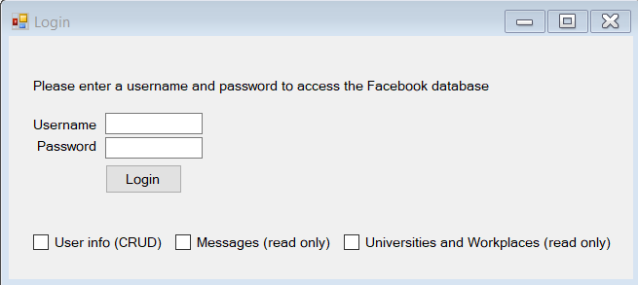

Figure 7 Login Screen

When the app is first launched, the user will be greeted with a login screen to access the Facebook database. The “Username” and “Password” fields are assigned within MySQL Workbench by the admin as they determine and set access rights for each user who logs into the database.

The check boxes at the bottom of the window are selected depending on which form(s) the user would like to open. If the check box is selected, the form will be opened.

When correct credentials have been entered and the user has selected which form(s) they would like to open, C# will make a connection with the SQL server.

## Users form

### The code behind the Users form

using System;

using System.Collections.Generic;

using System.ComponentModel;

using System.Data;

using System.Drawing;

using System.Linq;

using System.Text;

using System.Threading.Tasks;

using System.Windows.Forms;

using MySql.Data.MySqlClient;

namespace facebook

{

public partial class Users : Form

{

public Users()

{

InitializeComponent();

}

private void performSQLCommand(string query)

{

using (MySqlConnection connection = new MySqlConnection(Login.connectionString))

{

connection.Open();

MySqlCommand cmd = new MySqlCommand(query, connection);

MySqlDataAdapter sqlDA = new MySqlDataAdapter(cmd);

DataTable userDataTable = new DataTable();

sqlDA.Fill(userDataTable);

UserDataGrid.DataSource = userDataTable;

connection.Close();

}

}

// Specific queries

private void comboBox1_SelectedIndexChanged(object sender, EventArgs e)

{

using (MySqlConnection connection =

new MySqlConnection(Login.connectionString))

{

try

{

string[] queries =

{@"SELECT COUNT(*) AS NumFriends, UserID, FirstName, LastName, Gender, Hometown, CurrentTown FROM fb.friends

INNER JOIN fb.users ON friends.UserID1 = users.UserID

GROUP BY UserID

ORDER BY NumFriends DESC;",

@"SELECT * FROM fb.users

WHERE UserID % 985 = 0

ORDER BY UserID;",

"SELECT * FROM fb.users WHERE Gender = \"Male\" ORDER BY FirstName;",

"SELECT * FROM fb.users WHERE Gender = \"Female\" AND UserID % 985 = 0 ORDER BY UserID;",

"SELECT * FROM fb.users WHERE Gender = \"Male\" AND UserID % 985 = 0 ORDER BY LastName;",

@"SELECT COUNT(*) AS NumMessages, UserID, FirstName, LastName, Gender, Hometown, CurrentTown FROM fb.messages

INNER JOIN fb.users ON messages.Users_UserID = users.UserID

GROUP BY UserID

ORDER BY NumMessages DESC

LIMIT 5;",

@"SELECT universities.cnt + workplaces.cnt AS ""Uni + Work locations"", users.UserID, FirstName, LastName, Gender, Hometown, CurrentTown

FROM (SELECT UserID, COUNT(*) AS cnt FROM universities GROUP BY UserID) universities

JOIN (SELECT UserID, COUNT(*) AS cnt FROM workplaces GROUP BY UserID) workplaces

ON universities.UserID = workplaces.UserID

JOIN users

ON users.UserID = universities.UserID

ORDER BY (universities.cnt + workplaces.cnt) DESC",

@"SELECT COUNT(*) AS ""NumFriends"",

m.Users_UserID AS 'SenderID',

m.Users_UserID1 AS 'ReceiverID',

CONCAT(Sender.FirstName, ' ', Sender.LastName) AS 'SenderName',

CONCAT(Receiver.FirstName, ' ', Receiver.LastName) AS 'ReceiverName'

FROM messages m

INNER JOIN users Sender

ON m.Users_UserID = Sender.UserID

INNER JOIN users Receiver

ON m.Users_UserID1 = Receiver.UserID

GROUP BY Users_UserID, Users_UserID1

ORDER BY COUNT(*) DESC;"

};

string query = queries[UserQueries.SelectedIndex];

performSQLCommand(query);

}

catch

{ }

}

}

// Query all users

private void ViewUsersButton_Click(object sender, EventArgs e)

{

using (MySqlConnection connection = new MySqlConnection(Login.connectionString))

{

string query = "SELECT * FROM fb.users";

performSQLCommand(query);

}

}

// Add user

private void AddUserButton_Click(object sender, EventArgs e)

{

if (FirstName.Text != "" && LastName.Text != "" && Gender.Text != "")

{

string query = "INSERT INTO fb.users (FirstName, LastName, Gender, RelationshipStatus, HomeTown, CurrentTown) VALUES(\"" + FirstName.Text + " \", \"" + LastName.Text + "\",\"" + Gender.Text + "\",\"" + RelationshipStat.Text + "\",\"" + Hometown.Text + "\",\"" + CurrentTown.Text + "\");";

performSQLCommand(query);

MessageBox.Show("User added, please take note of your UserID shown on the next page.");

// Refresh the data grid view

string query1 = "SELECT * FROM fb.users ORDER BY UserID DESC LIMIT 1";

performSQLCommand(query1);

}

else

{

MessageBox.Show("Please enter a First Name, Last Name and Gender to add a new user!");

}

}

// Delete User with UserID

private void DeleteUserButton_Click(object sender, EventArgs e)

{

if (UserIDbox.Text != "")

{

DialogResult dialogResult = MessageBox.Show("Are you sure you want to delete this user?", "Delete user",

MessageBoxButtons.YesNo, MessageBoxIcon.Error);

if (dialogResult == DialogResult.Yes)

{

// Delete the user with UserID entered in UserIDbox.Text

string query = "DELETE FROM fb.users WHERE UserID =" + UserIDbox.Text;

performSQLCommand(query);

// Refresh the data grid view

string query1 = "SELECT * FROM fb.users WHERE UserID = 0";

performSQLCommand(query1);

}

else if (dialogResult == DialogResult.No)

{

}

}

else

{

MessageBox.Show("Please enter UserID to delete!");

}

}

// look for User info with ID

private void textBox1_TextChanged(object sender, EventArgs e)

{

using (MySqlConnection connection = new MySqlConnection(Login.connectionString))

{

try

{

string query = "SELECT * FROM fb.users WHERE UserID =" + UserIDbox.Text + ";";

performSQLCommand(query);

}

catch

{

string query = "SELECT * FROM fb.users WHERE UserID = 0;";

performSQLCommand(query);

}

}

}

// Look for userID with info

private void SearchIDButton_Click(object sender, EventArgs e)

{

using (MySqlConnection connection = new MySqlConnection(Login.connectionString))

{

if (Gender.Text != "")

{

string query = @"SELECT * FROM users

WHERE UserID like '%" + UserIDbox.Text + @"%'

AND FirstName like '%" + FirstName.Text + @"%'

AND LastName like '%" + LastName.Text + @"%'

AND Gender = '" + Gender.Text + @"'

AND RelationshipStatus like '%" + RelationshipStat.Text + @"%'

AND HomeTown like '%" + Hometown.Text + @"%'

AND CurrentTown like '%" + CurrentTown.Text + @"%'";

performSQLCommand(query);

}

else

{

MessageBox.Show("Please at least enter your gender!");

}

}

}

// Update user info

private void UpdateUserButton_Click(object sender, EventArgs e)

{

if (UserIDbox.Text != "")

{

MySqlConnection connection = new MySqlConnection(Login.connectionString);

connection.Open();

if (FirstName.Text != "")

{

string query = "UPDATE fb.users SET FirstName = '" + FirstName.Text + "' WHERE UserID = " + UserIDbox.Text;

MySqlCommand cmd = new MySqlCommand(query, connection);

cmd.ExecuteNonQuery();

}

if (LastName.Text != "")

{

string query = "UPDATE fb.users SET LastName = '" + LastName.Text + "' WHERE UserID = " + UserIDbox.Text;

MySqlCommand cmd = new MySqlCommand(query, connection);

cmd.ExecuteNonQuery();

}

if (Gender.Text != "")

{

string query = "UPDATE fb.users SET Gender = '" + Gender.Text + "' WHERE UserID = " + UserIDbox.Text;

MySqlCommand cmd = new MySqlCommand(query, connection);

cmd.ExecuteNonQuery();

}

if (RelationshipStat.Text != "")

{

string query = "UPDATE fb.users SET RelationshipStatus = '" + RelationshipStat.Text + "' WHERE UserID = " + UserIDbox.Text;

MySqlCommand cmd = new MySqlCommand(query, connection);

cmd.ExecuteNonQuery();

}

if (Hometown.Text != "")

{

string query = "UPDATE fb.users SET HomeTown = '" + Hometown.Text + "' WHERE UserID = " + UserIDbox.Text;

MySqlCommand cmd = new MySqlCommand(query, connection);

cmd.ExecuteNonQuery();

}

if (CurrentTown.Text != "")

{

string query = "UPDATE fb.users SET CurrentTown = '" + CurrentTown.Text + "' WHERE UserID = " + UserIDbox.Text;

MySqlCommand cmd = new MySqlCommand(query, connection);

cmd.ExecuteNonQuery();

}

MessageBox.Show("User updated");

// Refresh the data grid view

string query1 = "SELECT * FROM fb.users WHERE UserID = " + UserIDbox.Text;

performSQLCommand(query1);

connection.Close();

}

else

{

MessageBox.Show("Please enter a UserID to update!");

}

}

}

}

### The user interface

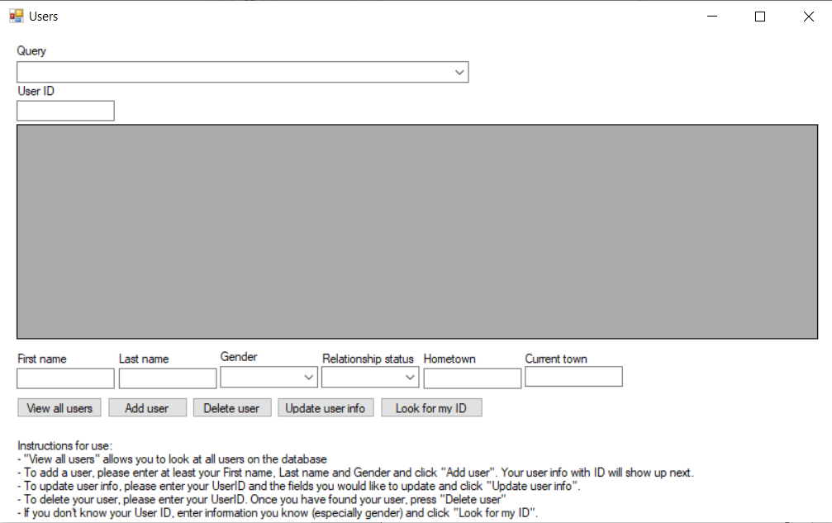

Figure 8 Users Form

This form is used to perform the entire CRUD cycle on the Facebook user’s information (“FirstName”, “LastName”, “Gender”, “RelationshipStatus”, “HomeTown”, “CurrentTown”). It provides instructions at the bottom of the form that tells the database user how to use the form to perform any of the CRUD functions.

### Create

To add a Facebook user, the form will at least require the user’s first name, last name and gender. If any of these fields are missing, a box will pop up to let the database user know to enter all those fields.

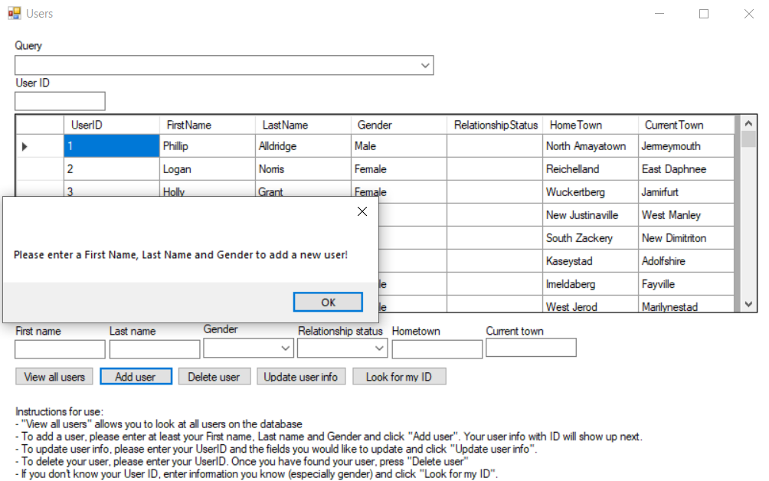

Figure 9 Message box pop up when insufficient entries entered for creating a new user in the database

The reason that this was coded this way is because Facebook also requires at least those 3 fields in order to make a new Facebook account. Hence, I am trying to mirror Facebook’s user interface as closely as possible.

When the user has been successfully added, another pop up will show and tell the database user to take note of the new user ID which will show up in the table along with the user info which was just added.

### Read

There are a few ways to read the data from the database:

1. Using the “View All Users” button  
   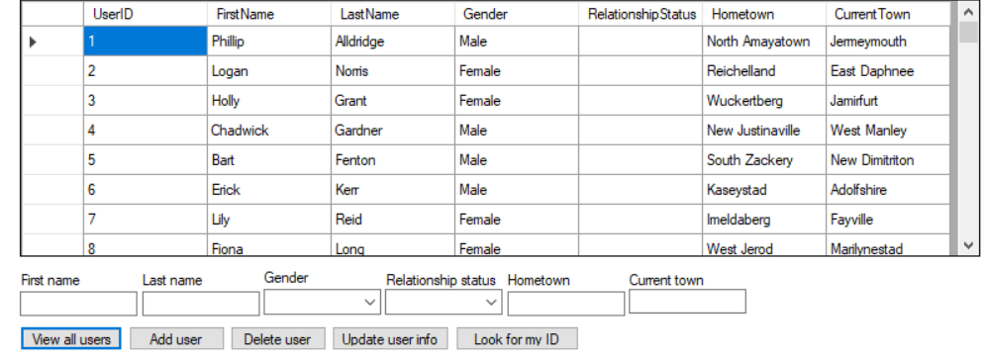

Figure 10 Table that is shown when "View all users" button has been selected

When the button is clicked, the database user will be able to view all of the users that are stored within the Facebook database. They are ordered in ascending order of UserID.

1. Using the “Query” combo box  
   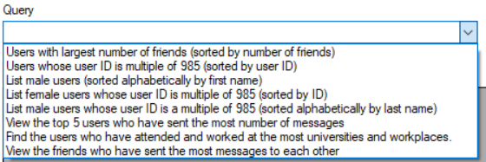

Figure 11 Reading database data by using Query combo box

The database user will be able to see a dropdown list of options to query and once they select the one that they want to view, the table with the appropriate query applied will display.

* 1. “Users with largest number of friends (sorted by number of friends)”  
     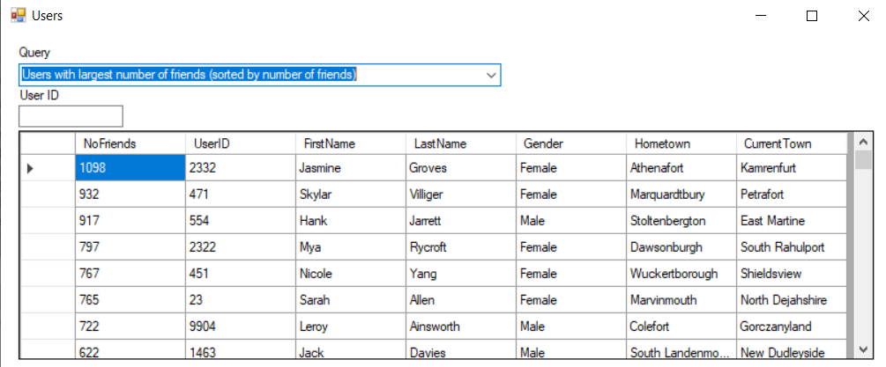

Figure 12 Table that is displayed when "Users with largest number of friends (sorted by number of friends)” query has been selected

We can verify that this query works by looking at the NoFriends column and seeing that the users are ordered in terms of the number of friends that they have.

The SQL query behind this selection is:

SELECT COUNT(*) AS NumFriends, UserID, FirstName, LastName, Gender, Hometown, CurrentTown FROM fb.friends

INNER JOIN fb.users ON friends.UserID1 = users.UserID

GROUP BY UserID

ORDER BY NumFriends DESC;

This query calls for the count of the number of friends that each user has and the rest of the users table by first doing an inner join of fb.users on friends.UserID1. An inner join is ideal for this situation as only the users who have friends should appear on the table, and all the UserIDs in the friends table should appear in the users table as well. After joining the two tables, the query then groups by the UserID – which will allow the COUNT(*) to only apply to each user. The last step is to order the users by the number of friends that they have.

* 1. “Users whose user ID is multiple of 985 (sorted by user ID)”  
     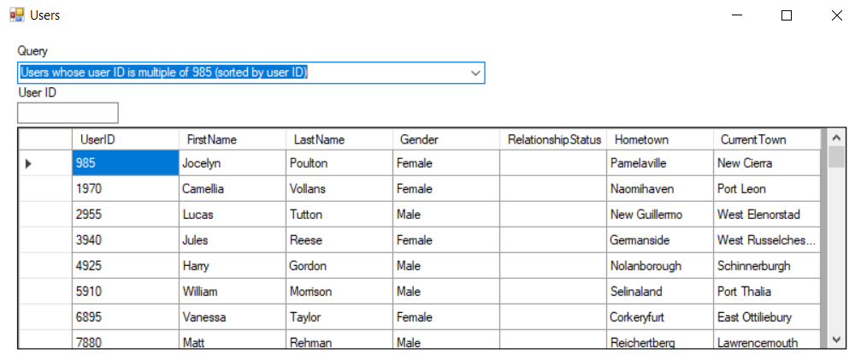

Figure 13 Table that is displayed when "Users whose user ID is multiple of 985 (sorted by userID)" query has been selected

We can verify that this query works by looking at the UserID column values (they are all multiples of 985).  
  
The SQL query behind this is:

SELECT * FROM fb.users   
WHERE UserID % 985 = 0

ORDER BY UserID;",

The query will return the entire users table where the UserID is a multiple of 985 and does so by making use of the modulo operator. Lastly, the users are ordered by their UserID.

* 1. “List male users (sorted alphabetically by first name)”  
     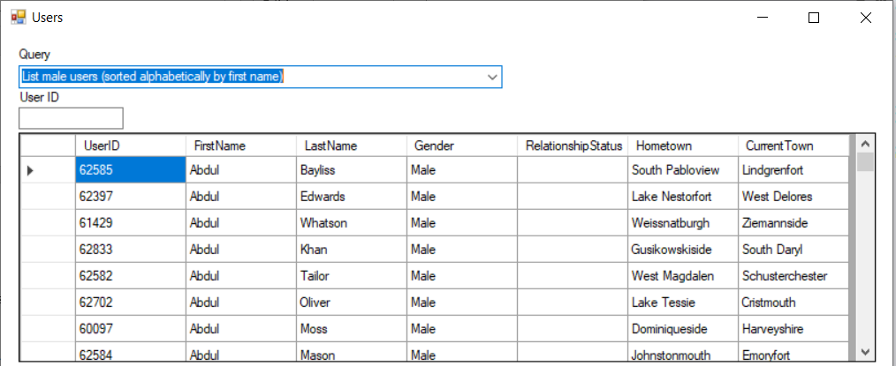

Figure 14 Table that is displayed when "List male users (sorted alphabetically by first name)" query has been selected

We can verify that this query works by looking at the “Gender” column (all the users in this table are males) and the “FirstName” column (they are sorted in ascending alphabetical order).  
  
The SQL query behind this is:

SELECT * FROM fb.users

WHERE Gender = \"Male\"

ORDER BY FirstName;

The query returns the users table that has the “Gender” column filtered so that it only returns entries that are “Male”. Lastly, the users are ordered by their first name.

* 1. “List female users whose user ID is multiple of 985 (sorted by ID)”  
     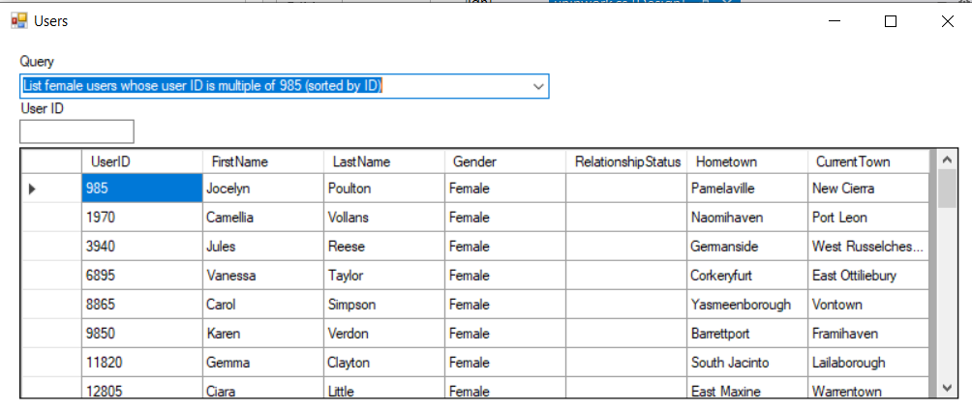

Figure 15 Table that is displayed when "List femae users whose user ID is multiple of 985 (sorted by ID)" query has been selected

We can verify that this query works by looking at the “UserID” column (all of the UserID’s are multiples of 985) and the “Gender” column (all the users in this table are female).  
  
SELECT * FROM fb.users

WHERE Gender = \"Female\" AND UserID % 985 = 0

ORDER BY UserID;  
This query returns the entire users table that has the “Gender” column filtered for “Female” and also the “UserID” column filtered such that all of them are multiples of 985 (this filter is done with the modulo operator).

* 1. “List male users whose user ID is a multiple of 985 (sorted alphabetically by last name)”  
     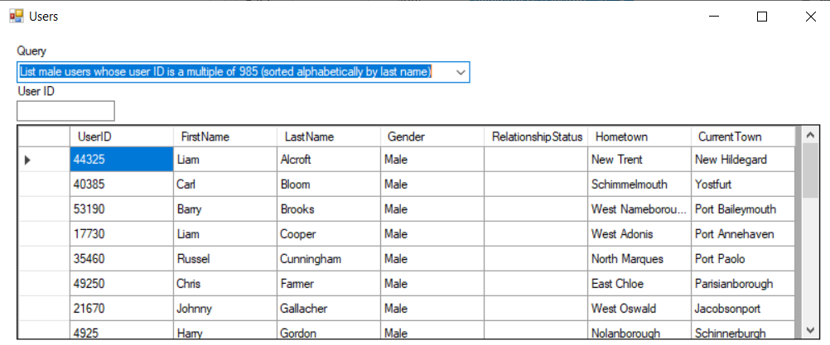

Figure 16 Table that is displayed when "List male users whose user ID is a multiple of 985 (sorted alphabetically by last name)" query has been selected

We can verify that this query works by looking at the “Gender” column – all of the users listed are male – the “UserID” column (they are all multiples of 985), and the “LastName” column (the last names are sorted in alphabetical, ascending order).

SELECT * FROM fb.users

WHERE Gender = \"Male\" AND UserID % 985 = 0

ORDER BY LastName;

This query returns the users table with filters on the “Gender” column for “Male’ and on the “UserID” column for userIDs that are multiples of 985 (using the modulo operator). Lastly, the query orders the users by their last name.

The next 3 queries are not requested in the assignment, they were created to showcase more SQL queries and the kind of information that can be extracted with them.

* 1. “View the top 5 users who have sent the most number of messages”  
     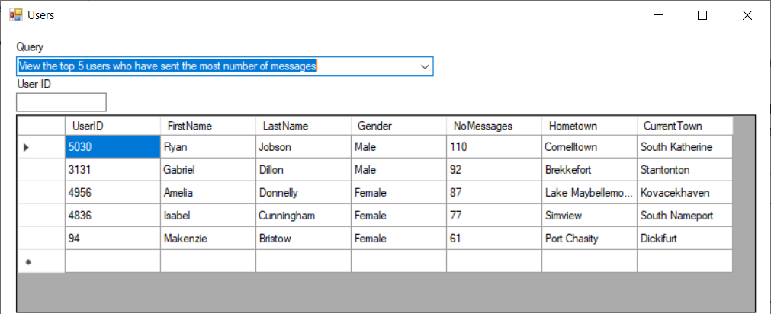

Figure 17 Table that is displayed when "View the top 5 users who have sent the most number of messages" query has been selected

This table and the next two tables are additional queries that have been created with more complex SQL queries.   
To verify that this query works, look at the “NoMessages” column and see that it is ordered in descending order.

The SQL query behind this is:

SELECT COUNT(*) AS NumMessages, UserID, FirstName, LastName, Gender, Hometown, CurrentTown FROM fb.messages

INNER JOIN fb.users ON messages.Users_UserID = users.UserID

GROUP BY UserID

ORDER BY NumMessages DESC

LIMIT 5;"

The query returns the number of messages that each user has sent and the rest of the user information. However, it limits the table to only display the top 5 users who have sent the most messages. It does this by first doing an inner join of the messages and users table, grouping by UserID – the COUNT(*) statement will then find the number of messages each user has sent, ordering the users by the number of messages that they have sent and limiting the number of users displayed to 5.

* 1. “Find the users who have attended and worked at the most universities and workplaces”  
     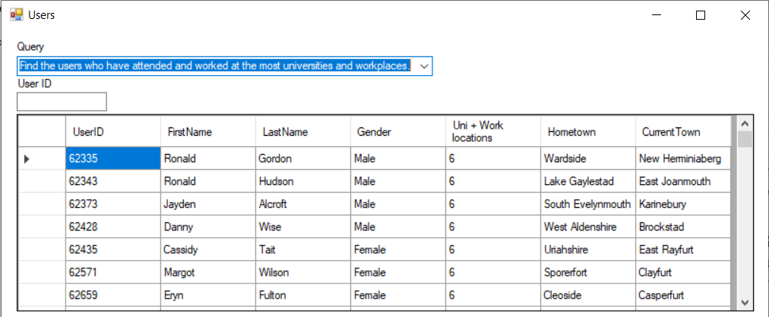

Figure 18 Table that is displayed when "Find the users who have attended and worked at the most universities and workplaces" query has been selected

To verify that this query works, look at the “Uni + Work locations” column and see that it is ordered in descending order.

The SQL query used for this is:

SELECT universities.cnt + workplaces.cnt AS ""Uni + Work locations"", users.UserID, FirstName, LastName, Gender, Hometown, CurrentTown

FROM (SELECT UserID, COUNT(*) AS cnt

FROM universities GROUP BY UserID) universities

JOIN (SELECT UserID, COUNT(*) AS cnt

FROM workplaces GROUP BY UserID) workplaces

ON universities.UserID = workplaces.UserID

JOIN users

ON users.UserID = universities.UserID

ORDER BY (universities.cnt + workplaces.cnt) DESC

This query joins 3 tables together, finds the number of universities that a user has attended and saves it as universities.cnt, the number of workplaces that a user has worked at and saves it as workplaces.cnt and adds the two values together. It then orders the users by this sum.

* 1. “View the friends who have sent the most messages to each other”  
     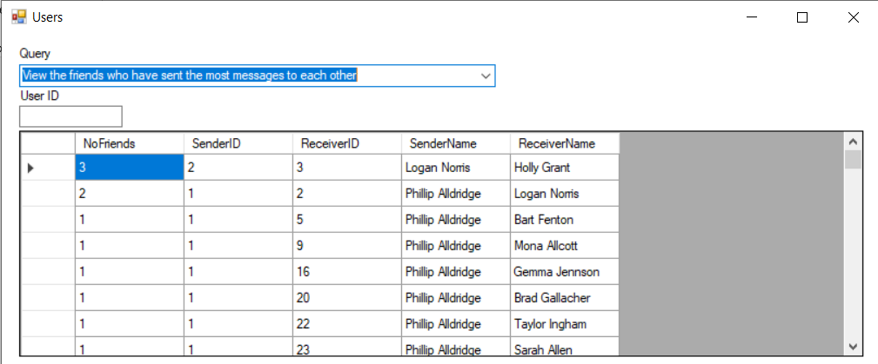

Figure 19 Table that is displayed when "View the friends who have sent the most messages to each other" query has been selected

To verify that this query works, look at the “NumFriends” column and see that it is ordered in descending order.   
Note: in the original database provided, the SenderID and ReceiverID combinations were all unique, so in order to verify that this query worked, I created additional entries, hence the values 3 and 2 seen in the first 2 rows.

This table was created with the following SQL query:

SELECT COUNT(*) AS ""NumFriends"",m.Users_UserID AS 'SenderID',m.Users_UserID1 AS 'ReceiverID',CONCAT(Sender.FirstName, ' ', Sender.LastName) AS 'SenderName',CONCAT(Receiver.FirstName, ' ', Receiver.LastName) AS 'ReceiverName'

FROM messages m

INNER JOIN users Sender

ON m.Users_UserID = Sender.UserID

INNER JOIN users Receiver

ON m.Users_UserID1 = Receiver.UserID

GROUP BY Users_UserID, Users_UserID1

ORDER BY COUNT(*) DESC

The query joins the users table with the messages table together twice on SenderID and ReceiverID. This was done so that the first name and last name of the sender and receiver can be extracted from the users table, concatenated together and displayed on the same table as the messages table.

1. Using the “UserID” textbox  
   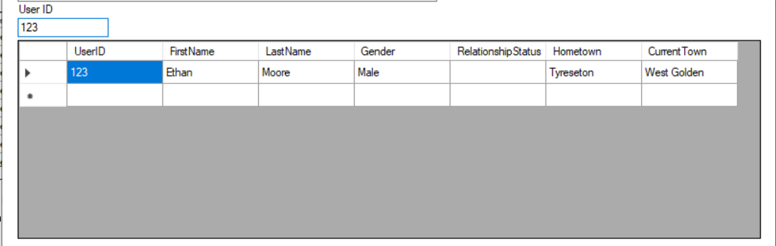

Figure 20 Reading data with the User ID textbox to query for a specific user

When the database user enters any UserID into the textbox, the user info that is within the database will be shown. If the UserID does not exist within the database, an empty table will be shown.

1. Using the “Look for my ID” button   
   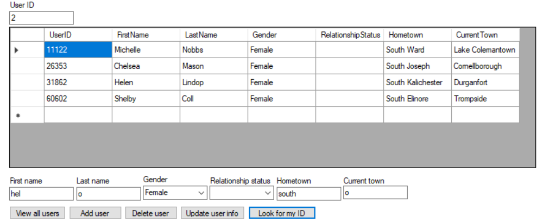

Figure 21 Using the "Look for my ID" button to query for specific users that match fields entered in the “First name”, “Last name”, “Gender”, “Relationship Status”, “Hometown” and “Current town” textboxes

To use this function, the user has to at least enter their gender. Any of the additional fields can be entered fully (full name), partially (maybe another alias that they go by), or not at all (left empty) and the table will show a list of accounts that match the fields entered.   
This button was created mainly for users who might have forgotten their UserID and need it to perform other functions in the CRUD cycle.

### Update

To update user info, the database user will have to enter the UserID and fields that they would like to update and then click on the “Update user info” button. Once this is done, the table will display the user’s updated information. This was coded this way in order to reduce error of entry. This method ensures that the database user knows exactly which UserID they would like to update, and forces them to ensure that it is the correct user; farther, the database user will not have to scroll through the entire table just to look for the user they want to update. Otherwise, if the database user were allowed to edit information directly in the table, not only would it be a hassle to find the user, but it would also be quite intrusive and there would be a lot of space for human error.

If no UserID is entered, the form will prompt the database user to enter a UserID.

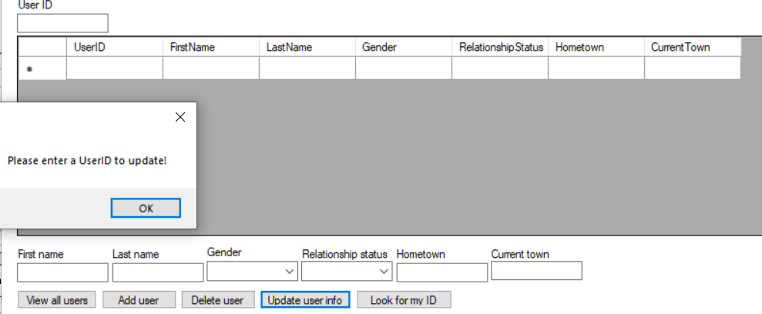

Figure 22 Message box pop up when no User ID has been entered to update

### Delete

To delete user info, the database user will need to enter the UserID and then click the “Delete user” button. Once the user has been deleted, an empty table will be displayed to show that the user has been deleted. The logic behind this code is also the same as the logic behind the “Update” code – less intruision, more precision.

If no UserID has been entered, the form will prompt the database user to enter a UserID.

## Extra forms

The following forms, Messages and Uninwork, were created in order to explore the C# and MySQL language and the user interface of Visual studio and MySQL Workbench more. It’s important to note that these forms are read only and it is not possible to perform the full CRUD cycle on them.

### Messages form

#### The code behind the Messages form

using System;

using System.Collections.Generic;

using System.ComponentModel;

using System.Data;

using System.Drawing;

using System.Linq;

using System.Text;

using System.Threading.Tasks;

using System.Windows.Forms;

using MySql.Data.MySqlClient;

namespace facebook

{

public partial class Messages : Form

{

public Messages()

{

InitializeComponent();

}

private void performSQLCommand(string query)

{

using (MySqlConnection connection = new MySqlConnection(Login.connectionString))

{

connection.Open();

MySqlCommand cmd = new MySqlCommand(query, connection);

MySqlDataAdapter sqlDA = new MySqlDataAdapter(cmd);

DataTable customerDataTable = new DataTable();

sqlDA.Fill(customerDataTable);

MessagesDataGrid.DataSource = customerDataTable;

connection.Close();

}

}

private void AllMessagesButton_Click(object sender, EventArgs e)

{

using (MySqlConnection connection = new MySqlConnection(Login.connectionString))

{

string query = @"SELECT

m.Users_UserID AS 'SenderID',

m.Users_UserID1 AS 'ReceiverID',

CONCAT(Sender.FirstName, ' ', Sender.LastName) AS 'SenderName',

CONCAT(Receiver.FirstName, ' ', Receiver.LastName) AS 'ReceiverName',

m.DateTime,

m.Messages

FROM messages m

INNER JOIN users Sender

ON m.Users_UserID = Sender.UserID

INNER JOIN users Receiver

ON m.Users_UserID1 = Receiver.UserID";

performSQLCommand(query);

}

}

private void SenderBox_TextChanged(object sender, EventArgs e)

{

}

private void SearchButton_Click(object sender, EventArgs e)

{

using (MySqlConnection connection = new MySqlConnection(Login.connectionString))

{

string query = @"SELECT

m.Users_UserID AS 'SenderID',

m.Users_UserID1 AS 'ReceiverID',

CONCAT(Sender.FirstName, ' ', Sender.LastName) AS 'SenderName',

CONCAT(Receiver.FirstName, ' ', Receiver.LastName) AS 'ReceiverName',

m.DateTime,

m.Messages

FROM messages m

INNER JOIN users Sender

ON m.Users_UserID = Sender.UserID

INNER JOIN users Receiver

ON m.Users_UserID1 = Receiver.UserID

WHERE Users_UserID like '%" + SenderBox.Text + @"%'

AND Users_UserID1 like'%" + ReceiverBox.Text + @"%'

AND Messages like '%" + MessageBox.Text + @"%';";

performSQLCommand(query);

}

}

private void monthCalendar1_DateChanged(object sender, DateRangeEventArgs e)

{

using (MySqlConnection connection = new MySqlConnection(Login.connectionString))

{

string query = @"SELECT

m.Users_UserID AS 'SenderID',

m.Users_UserID1 AS 'ReceiverID',

CONCAT(Sender.FirstName, ' ', Sender.LastName) AS 'SenderName',

CONCAT(Receiver.FirstName, ' ', Receiver.LastName) AS 'ReceiverName',

m.DateTime,

m.Messages

FROM messages m

INNER JOIN users Sender

ON m.Users_UserID = Sender.UserID

INNER JOIN users Receiver

ON m.Users_UserID1 = Receiver.UserID

WHERE CAST(DateTime AS DATE) like '" + monthCalendar1.SelectionStart.ToString("yyyy-MM-dd") + "';";

performSQLCommand(query);

}

}

}

}

#### The user interface

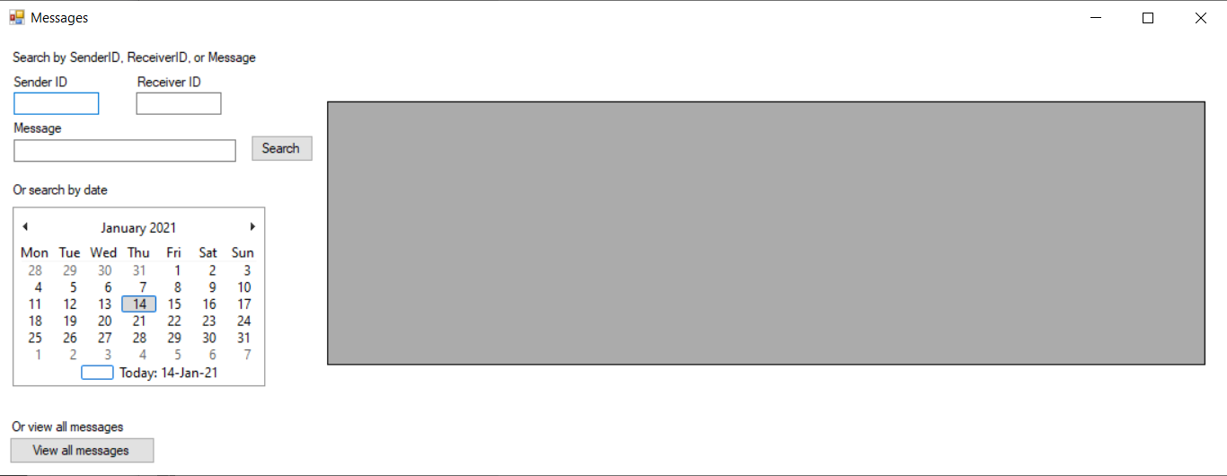

Figure 23 Messages Form

Within the messages form, there are several ways to query the messages table.

##### View all messages button

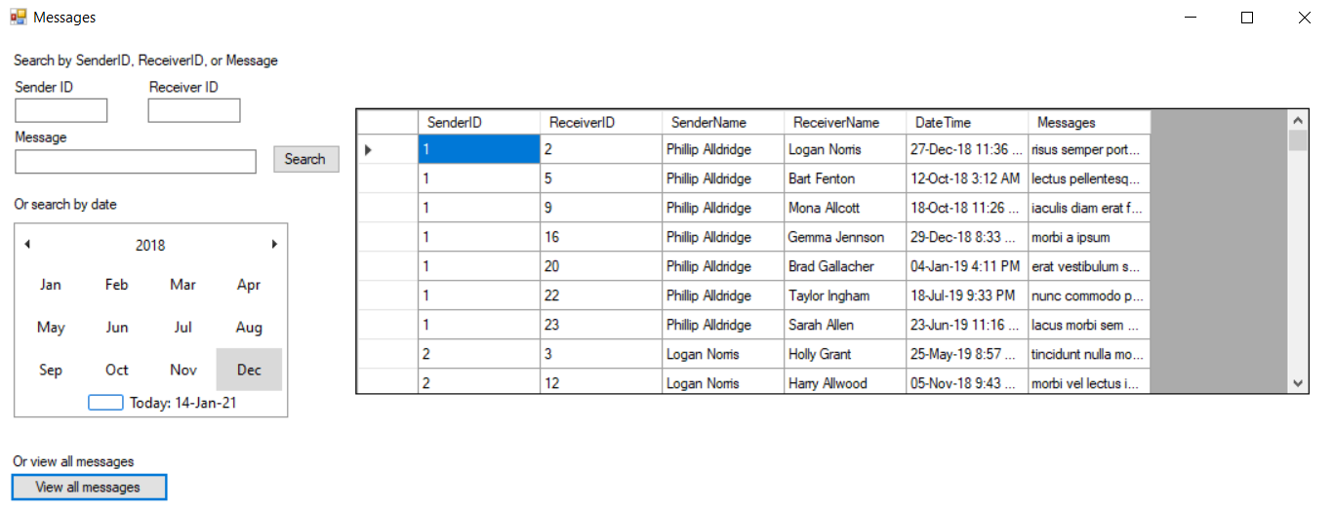

Figure 24 Table that is displayed when "View all messages" button has been selected

When this button is clicked, the full table of all messages within the database is displayed. If comparing the original messages table provided and the table which is seen above, it should be noted that the one in the data grid view has 2 extra columns. These columns for SenderName and ReceiverName were coded in with the JOIN and CONCAT function in SQL. They allow the database user to easily know the names of the sender and receiver of each message and allows for clarification.

SELECT   
m.Users_UserID AS 'SenderID',   
m.Users_UserID1 AS 'ReceiverID',   
CONCAT(Sender.FirstName, ' ', Sender.LastName) AS 'SenderName',  
CONCAT(Receiver.FirstName, ' ', Receiver.LastName) AS 'ReceiverName',  
m.DateTime,  
m.Messages  
FROM messages m  
INNER JOIN users Sender  
ON m.Users_UserID = Sender.UserID  
INNER JOIN users Receiver  
ON m.Users_UserID1 = Receiver.UserID";

As seen with the code, the messages table was joined with the users table twice – once to get the name of the sender, and once more to get the name of the receiver.

##### Search button

The search button is used alongside of the Sender ID, Receiver ID and Messages textbox. These textboxes work similar to the “Look for my ID” button in the Users form.

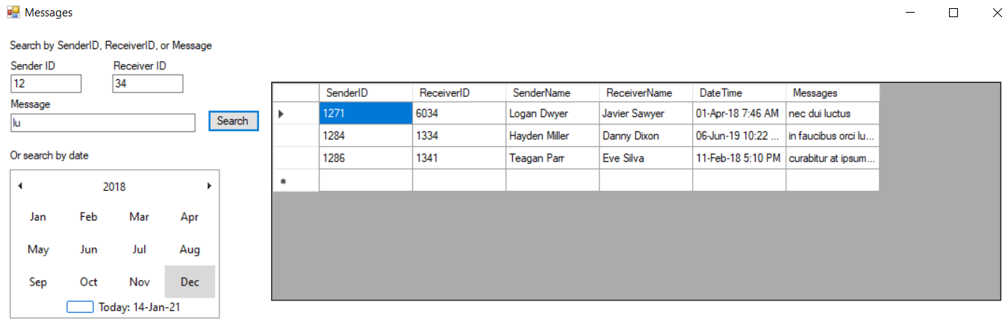

Figure 25 Table that is displayed when "Search" button is clicked, displaying rows that are similar to “Sender ID”,   
“Receiver ID”, “Message” textbox entries

By entering fields into the textboxes and clicking the Search button, the results that are similar to those which were entered will appear in the data grid view. If no messages match the fields which were entered into these textboxes, the table would simply be blank.

##### Calendar

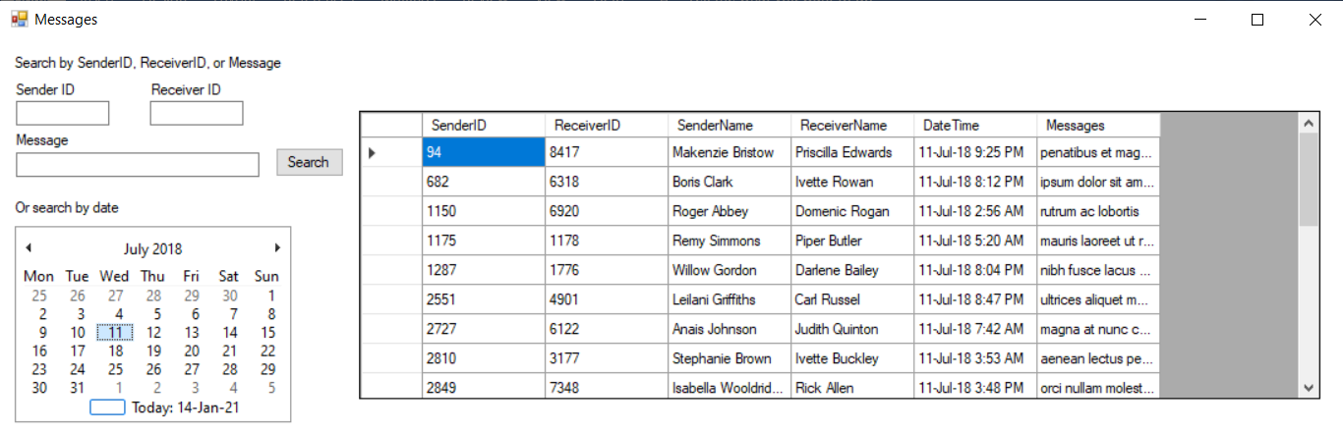

Figure 26 Table displaying messages sent on 11 July 2018

The calendar was an additional function within visual studio which I wanted to explore and learn how to utilize. In order to query with the calendar, the database user will search the calendar for the date which they want to view and the table will display all of the messages sent within that date. If there were no messages sent during the date which is searched, the table would simply be blank. The main struggles and learning curve behind this were to figure out the format in which C# returns dates from the calendar table, and how to link that format with the “DateTime” format in the database table. Although seemingly complicated, a simply line like the following did the trick:

WHERE CAST(DateTime AS DATE) like '" + monthCalendar1.SelectionStart.ToString("yyyy-MM-dd") + "';

### Uninwork form

#### The code behind uninwork form

using System;

using System.Collections.Generic;

using System.ComponentModel;

using System.Data;

using System.Drawing;

using System.Linq;

using System.Text;

using System.Threading.Tasks;

using System.Windows.Forms;

using MySql.Data.MySqlClient;

namespace facebook

{

public partial class uninwork : Form

{

public uninwork()

{

InitializeComponent();

}

private void performSQLCommandUni(string query)

{

using (MySqlConnection connection = new MySqlConnection(Login.connectionString))

{

connection.Open();

MySqlCommand cmd = new MySqlCommand(query, connection);

MySqlDataAdapter sqlDA = new MySqlDataAdapter(cmd);

DataTable userDataTable = new DataTable();

sqlDA.Fill(userDataTable);

UniGridView.DataSource = userDataTable;

connection.Close();

}

}

private void performSQLCommandWork(string query)

{

using (MySqlConnection connection = new MySqlConnection(Login.connectionString))

{

connection.Open();

MySqlCommand cmd = new MySqlCommand(query, connection);

MySqlDataAdapter sqlDA = new MySqlDataAdapter(cmd);

DataTable userDataTable = new DataTable();

sqlDA.Fill(userDataTable);

WorkGridView.DataSource = userDataTable;

connection.Close();

}

}

private void IDBox_TextChanged(object sender, EventArgs e)

{

// Show Username

try

{

using (MySqlConnection connection = new MySqlConnection(Login.connectionString))

{

string query1 = "SELECT CONCAT(FirstName, \" \", LastName) FROM fb.users WHERE UserID =" + IDBox.Text + ";";

connection.Open();

MySqlCommand cmd1 = new MySqlCommand(query1, connection);

MySqlDataReader reader = cmd1.ExecuteReader();

while (reader.Read())

{

var myString = reader.GetString(0);

Username.Text = "Username: " + myString;

}

connection.Close();

}

}

catch

{

Username.Text = "Username:";

}

// Show result in University grid

try

{

string query = "SELECT University FROM fb.universities WHERE UserID =" + IDBox.Text + ";";

performSQLCommandUni(query);

}

catch

{

string query = "SELECT University FROM fb.universities WHERE UserID = 0;";

performSQLCommandUni(query);

}

// Show results for Workplace Grid

try

{

string query = "SELECT Workplace FROM fb.workplaces WHERE UserID =" + IDBox.Text + ";";

performSQLCommandWork(query);

}

catch

{

string query = "SELECT Workplace FROM fb.workplaces WHERE UserID = 0;";

performSQLCommandWork(query);

}

}

private void label2_Click(object sender, EventArgs e)

{

}

private void uninwork_Load(object sender, EventArgs e)

{

}

}

}

#### The user interface

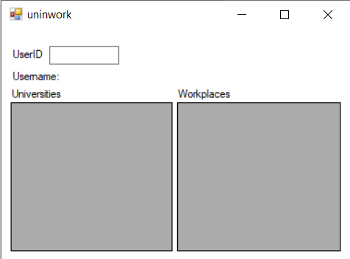

Figure 27 uninwork Form

This form is used to view the universities that the user has studied at and the workplaces that they have worked at.

The only way to query these tables is by using the UserID textbox.

The main thing that was learned in this form was how to convert a result from an SQL query into a string that can be displayed on a form.

# Test plan

To ensure that our user interface runs smoothly and the connection between the user interface and the database works, a test plan is provided to illustrate those.

## SQL Table Creation

### Verifying that the tables with appropriate data types are created

To verify that the code to create tables runs correctly, open an instance of MySQL Workbench, open a new SQL file and copy and paste the code in.

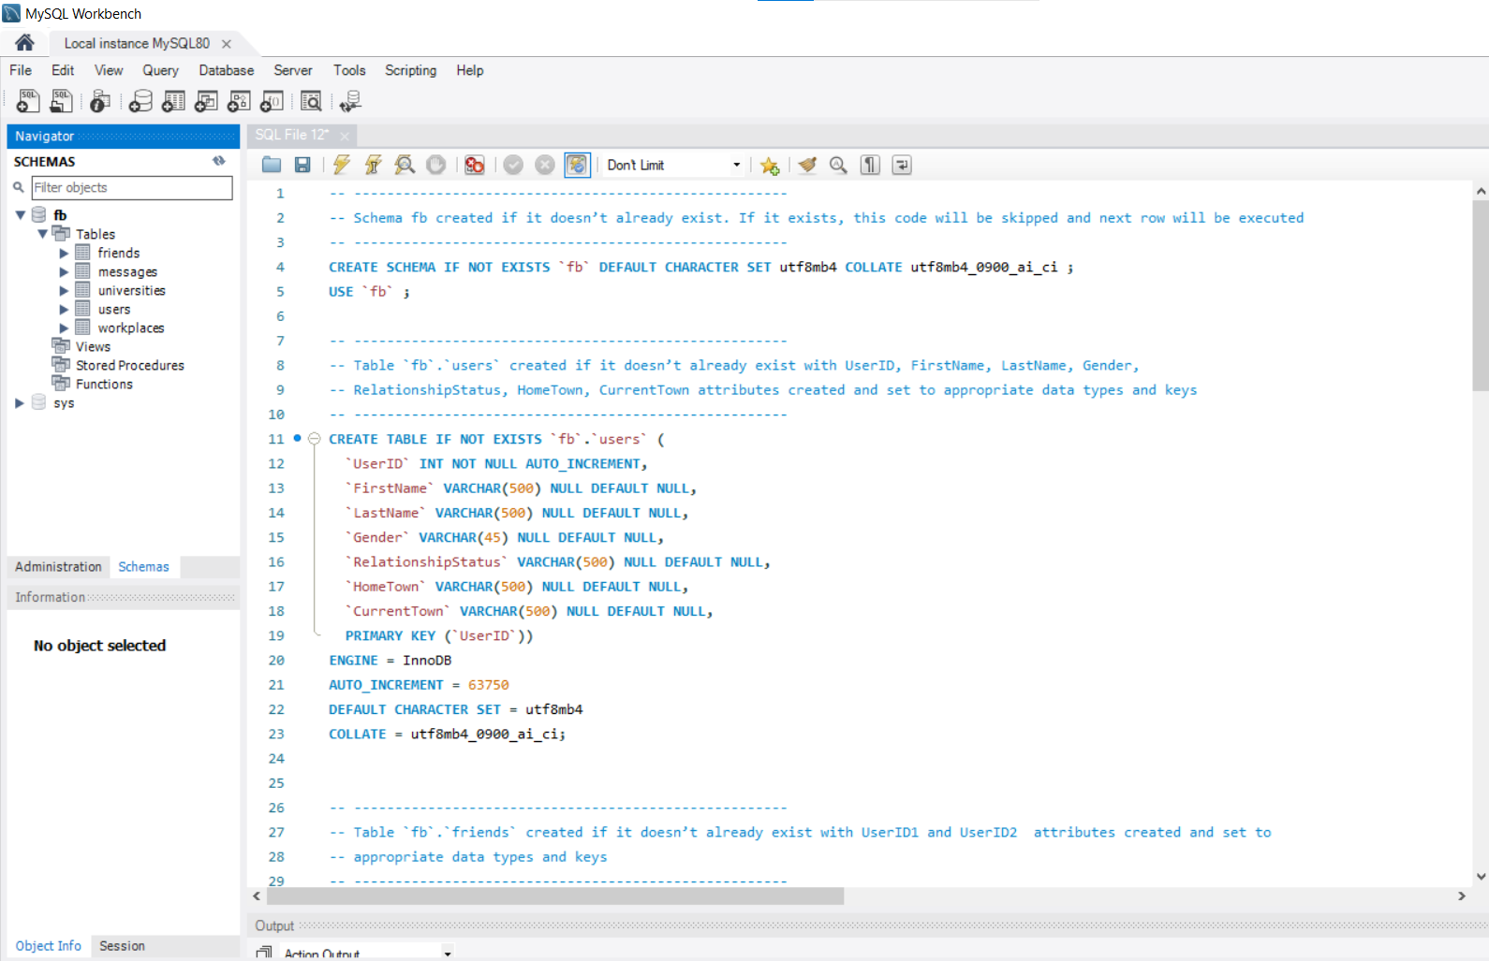

Figure 28 Running SQL statements above to create required tables

Once the code has run, the tables will appear on the left navigator bar. We can now take a closer look and see that the code has created the correct tables with the correct columns, foreign keys, and primary keys.

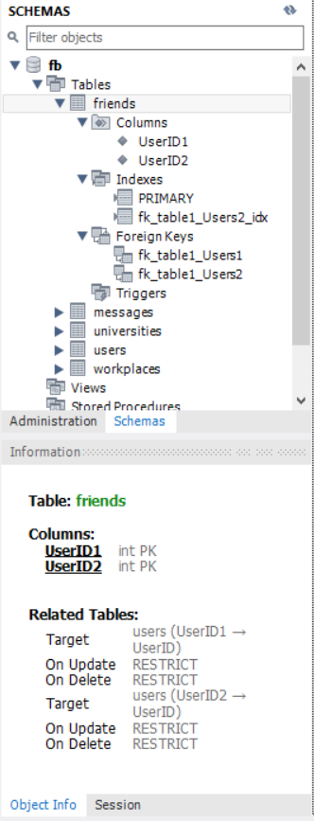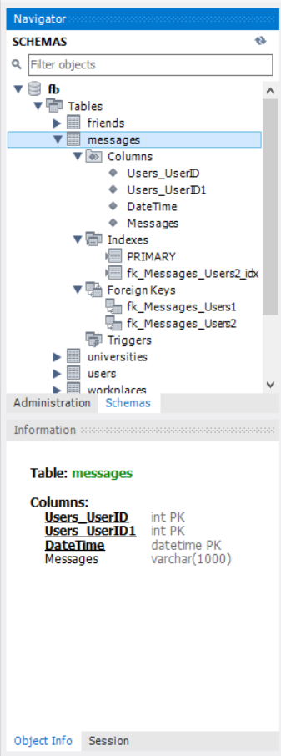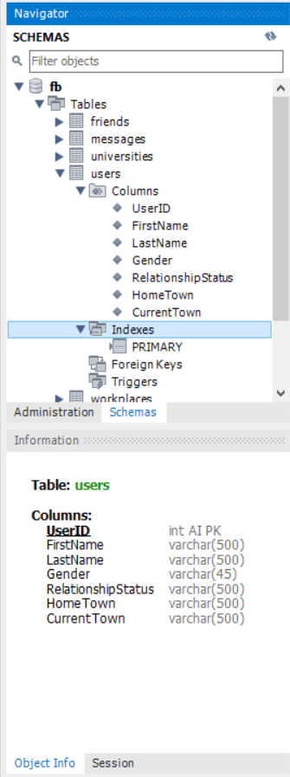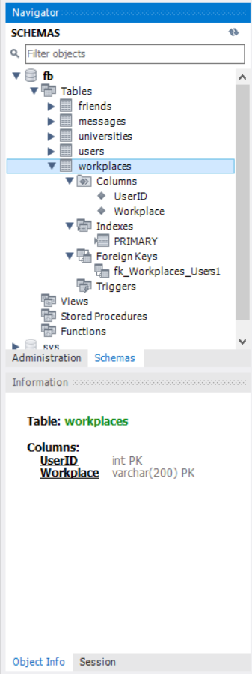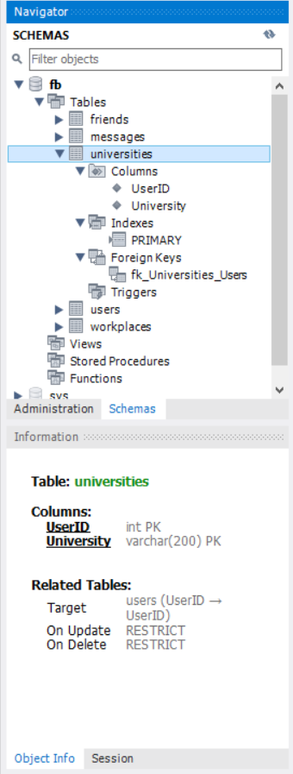

Figure 29 Information (columns, primary keys, foreign keys, etc.) of tables created

### Validating that the SQL queries produce appropriate tables and relationships

<https://dbdiagram.io/> is an online ERD generator which can produce an ERD diagram based on the SQL code which is imported. Hence, I will be using this website to validate that the queries above do produce the correct tables (users, universities, workplaces, messages, friends), one to many relationships and datatypes.

The figure below shows the <https://dbdiagram.io/> website. The left column contains the code which was imported and the right window shows the ERD diagram which was produced with the imported code. Hence, by looking at the figure below, we see that the correct tables, the correct datatypes per attribute, and the correct one-to-many relationships have been established (where there is one user in the users table and they will appear many times in all the other tables).

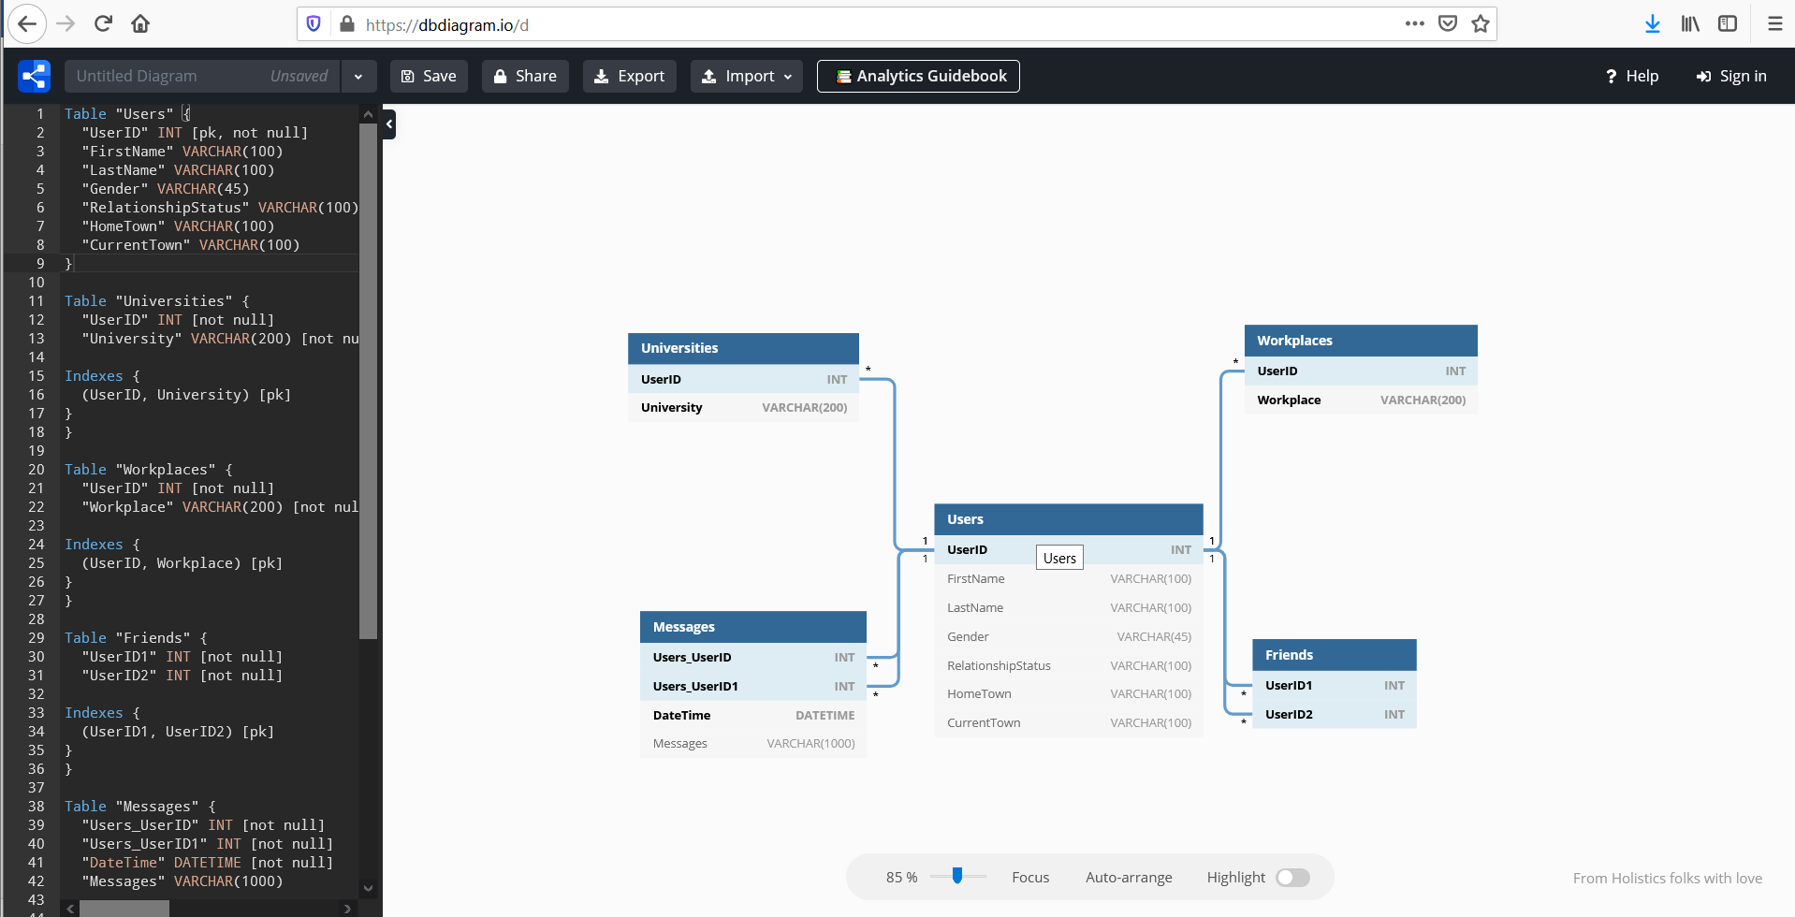

Figure 30 Validating SQL table creation with dbdiagram.io

The code which has been imported appears in the column on the left-hand side. The right window shows the ERD diagram.

## Populating the Database

### Validating that data can be imported correctly

In this section and the one below, I will be discussing validating and verifying that the data import is correct. For demonstration purposes, not all of the data will be imported in this section of “Populating the Database”. However, the examples posed in this document after this section will have all of the data imported into the database.

The main things that need to be validated when importing data into the database are the following:

1. Ensuring that the data types that were created during table creation is correct so that the data can be imported correctly
2. Check that special characters can be imported   
   This is needed especially for the users table as some names contained special characters that cannot be identified by UTF-8 encoding, and hence the data needs to be imported with latin2 instead.

### Verifying that data import with INSERT INTO statements is correct and accurate

To verify, I will show examples of data import in each of the tables.

#### Users data

Instead of importing the entire dataset, this example will show the import of the first 10 users and user 42 (which is the first user that had a special character, just to make sure that special characters can be imported). The following code was run to import the data stated and a select line was used to view the entire table.

INSERT INTO fb.users(UserID,FirstName,LastName,Gender,RelationshipStatus,HomeTown,CurrentTown) VALUES (1,'Phillip','Alldridge','Male',NULL,'North Amayatown','Jermeymouth');

INSERT INTO fb.users(UserID,FirstName,LastName,Gender,RelationshipStatus,HomeTown,CurrentTown) VALUES (2,'Logan','Norris','Female',NULL,'Reichelland','East Daphnee');

INSERT INTO fb.users(UserID,FirstName,LastName,Gender,RelationshipStatus,HomeTown,CurrentTown) VALUES (3,'Holly','Grant','Female',NULL,'Wuckertberg','Jamirfurt');

INSERT INTO fb.users(UserID,FirstName,LastName,Gender,RelationshipStatus,HomeTown,CurrentTown) VALUES (4,'Chadwick','Gardner','Male',NULL,'New Justinaville','West Manley');

INSERT INTO fb.users(UserID,FirstName,LastName,Gender,RelationshipStatus,HomeTown,CurrentTown) VALUES (5,'Bart','Fenton','Male',NULL,'South Zackery','New Dimitriton');

INSERT INTO fb.users(UserID,FirstName,LastName,Gender,RelationshipStatus,HomeTown,CurrentTown) VALUES (6,'Erick','Kerr','Male',NULL,'Kaseystad','Adolfshire');

INSERT INTO fb.users(UserID,FirstName,LastName,Gender,RelationshipStatus,HomeTown,CurrentTown) VALUES (7,'Lily','Reid','Female',NULL,'Imeldaberg','Fayville');

INSERT INTO fb.users(UserID,FirstName,LastName,Gender,RelationshipStatus,HomeTown,CurrentTown) VALUES (8,'Fiona','Long','Female',NULL,'West Jerod','Marilynestad');

INSERT INTO fb.users(UserID,FirstName,LastName,Gender,RelationshipStatus,HomeTown,CurrentTown) VALUES (9,'Mona','Allcott','Female',NULL,'Maryseland','East Mariana');

INSERT INTO fb.users(UserID,FirstName,LastName,Gender,RelationshipStatus,HomeTown,CurrentTown) VALUES (10,'Harvey','Hood','Male',NULL,'Isacchester','Ankundingland');

INSERT INTO fb.users(UserID,FirstName,LastName,Gender,RelationshipStatus,HomeTown,CurrentTown) VALUES (42,'Chadwick','Stuart','Male',NULL,'West Hannahfurt','Gu��annfort');

SELECT * FROM users

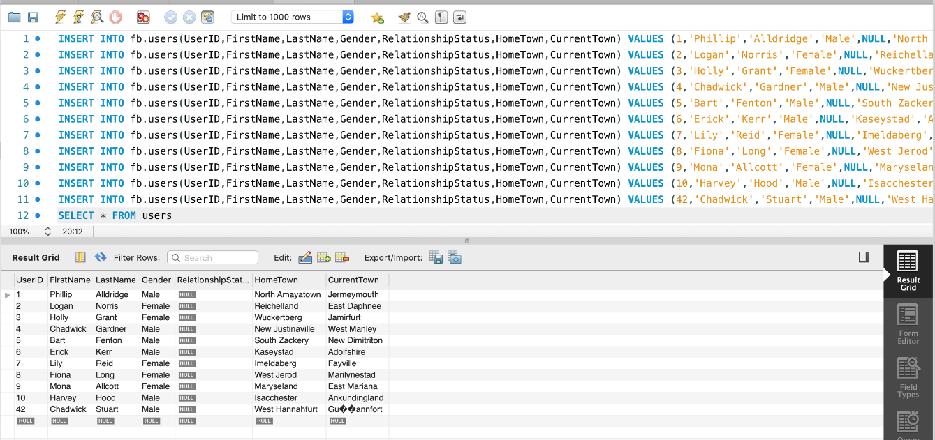

Figure 31 Users table populated with SQL INSERT INTO statements

If we cross check the table shown on the lower part of the picture, we can verify that the data has been imported correctly, including the row with a special character.

#### Friends data

We do the same thing for the friends table and import the first 9 rows of data.

INSERT INTO fb.friends(UserID1,UserID2) VALUES (1,2);

INSERT INTO fb.friends(UserID1,UserID2) VALUES (1,3);

INSERT INTO fb.friends(UserID1,UserID2) VALUES (1,4);

INSERT INTO fb.friends(UserID1,UserID2) VALUES (1,5);

INSERT INTO fb.friends(UserID1,UserID2) VALUES (1,6);

INSERT INTO fb.friends(UserID1,UserID2) VALUES (1,7);

INSERT INTO fb.friends(UserID1,UserID2) VALUES (1,8);

INSERT INTO fb.friends(UserID1,UserID2) VALUES (1,9);

INSERT INTO fb.friends(UserID1,UserID2) VALUES (1,10);

SELECT * FROM friends

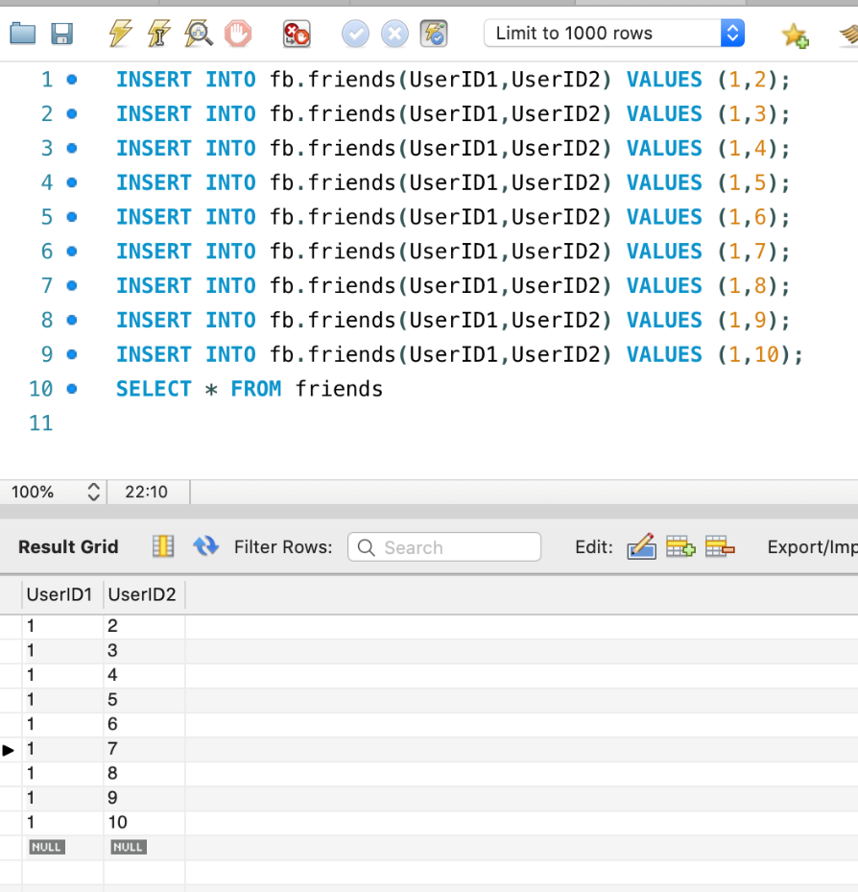

Figure 32 Friends table populated with SQL INSERT INTO statements

When cross checked, the table displays the userIDs correctly.

#### Universities data

The code chunk used to display results for universities is the following:

INSERT INTO fb.universities(UserID,University) VALUES (1,'');

INSERT INTO fb.universities(UserID,University) VALUES (2,'University of Oklahoma');

INSERT INTO fb.universities(UserID,University) VALUES (2,'University of Virginia');

INSERT INTO fb.universities(UserID,University) VALUES (3,'University of Texas at Austin');

INSERT INTO fb.universities(UserID,University) VALUES (4,'University at Buffalo SUNY');

INSERT INTO fb.universities(UserID,University) VALUES (5,'Wake Forest University');

INSERT INTO fb.universities(UserID,University) VALUES (5,'Stanford University');

INSERT INTO fb.universities(UserID,University) VALUES (6,'');

INSERT INTO fb.universities(UserID,University) VALUES (7,'');

INSERT INTO fb.universities(UserID,University) VALUES (8,'University of California, Los Angeles (UCLA)');

INSERT INTO fb.universities(UserID,University) VALUES (9,'');

INSERT INTO fb.universities(UserID,University) VALUES (10,'University of California, Los Angeles (UCLA)');

SELECT * FROM universities

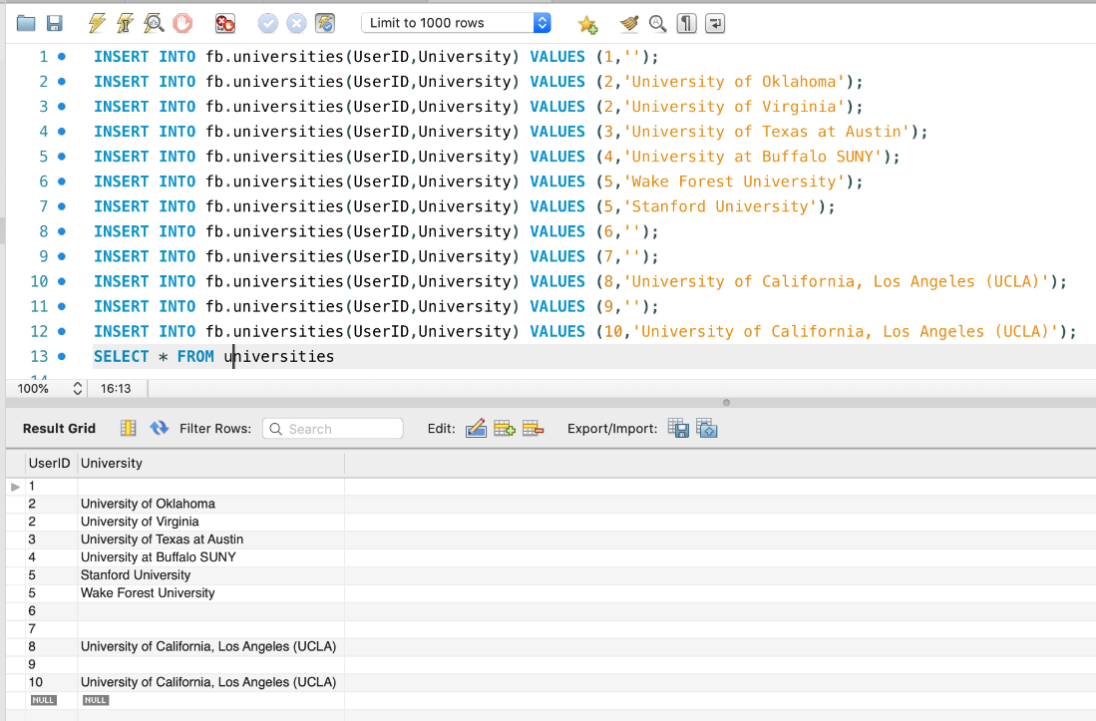

Figure 33 Universities table populated with SQL INSERT INTO statements

When cross checked, the data displayed in the table is accurate and can handle blank entries as not everyone has attended a university.

#### Workplaces data

The code that is used to import data for workplaces is the following:

INSERT INTO fb.workplaces(UserID,Workplace) VALUES (1,'AECOM');

INSERT INTO fb.workplaces(UserID,Workplace) VALUES (2,'');

INSERT INTO fb.workplaces(UserID,Workplace) VALUES (3,'21st Century Fox');

INSERT INTO fb.workplaces(UserID,Workplace) VALUES (3,'Apple Inc.');

INSERT INTO fb.workplaces(UserID,Workplace) VALUES (3,'Metro Cash&Carry');

INSERT INTO fb.workplaces(UserID,Workplace) VALUES (4,'Telekom');

INSERT INTO fb.workplaces(UserID,Workplace) VALUES (4,'ExxonMobil');

INSERT INTO fb.workplaces(UserID,Workplace) VALUES (4,'Carrefour');

INSERT INTO fb.workplaces(UserID,Workplace) VALUES (5,'21st Century Fox');

INSERT INTO fb.workplaces(UserID,Workplace) VALUES (6,'');

INSERT INTO fb.workplaces(UserID,Workplace) VALUES (7,'');

INSERT INTO fb.workplaces(UserID,Workplace) VALUES (8,'Carrefour');

INSERT INTO fb.workplaces(UserID,Workplace) VALUES (8,'Global Print');

INSERT INTO fb.workplaces(UserID,Workplace) VALUES (8,'Comodo');

INSERT INTO fb.workplaces(UserID,Workplace) VALUES (9,'Zepter');

INSERT INTO fb.workplaces(UserID,Workplace) VALUES (9,'BuzzFeed');

INSERT INTO fb.workplaces(UserID,Workplace) VALUES (9,'ENEL');

INSERT INTO fb.workplaces(UserID,Workplace) VALUES (10,'');

SELECT * FROM workplaces

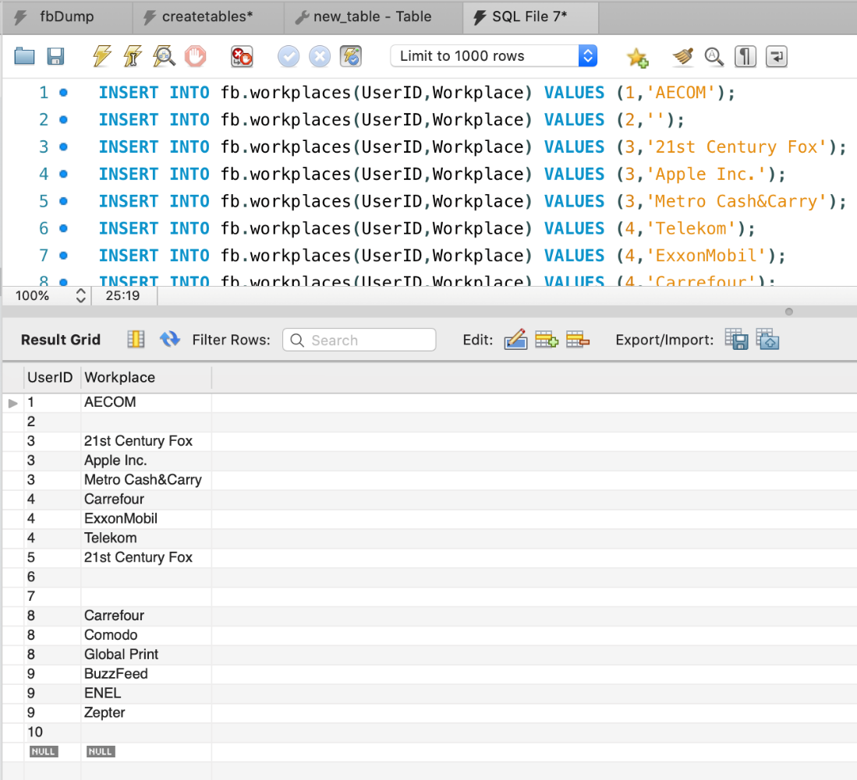

Figure 34 Workplaces table populated with SQL INSERT INTO statements

When cross checked, it can handle blank cases for users who might not have a workplace.

#### Messages data

The code used to import the messages data is the following:

INSERT INTO fb.messages(Users_UserID,Users_UserID1,DateTime,Messages) VALUES (1,2,'2018-12-27 11:36:41','risus semper porta volutpat quam pede lobortis ligula sit amet eleifend pede');

INSERT INTO fb.messages(Users_UserID,Users_UserID1,DateTime,Messages) VALUES (1,5,'2018-10-12 03:12:01','lectus pellentesque eget nunc donec quis orci eget orci vehicula condimentum');

INSERT INTO fb.messages(Users_UserID,Users_UserID1,DateTime,Messages) VALUES (1,9,'2018-10-18 23:26:43','iaculis diam erat fermentum justo nec condimentum neque sapien');

SELECT * FROM messages

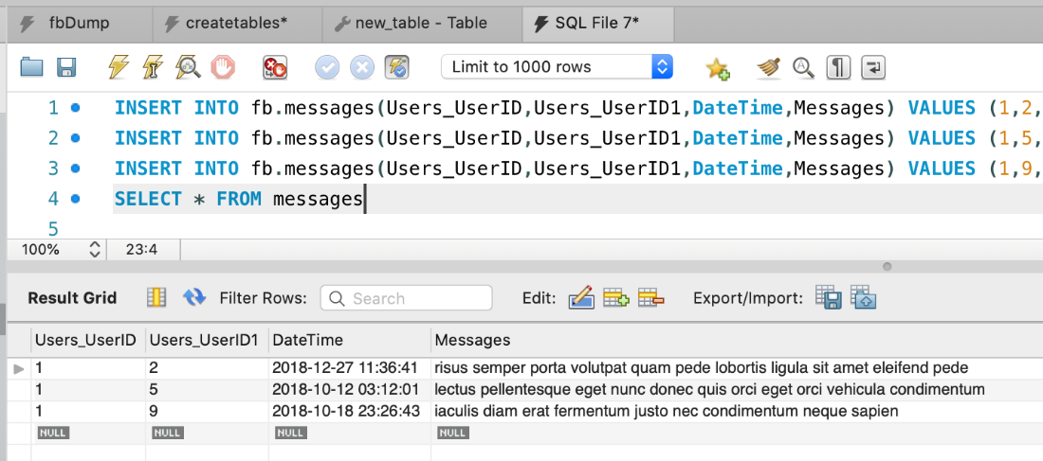

Figure 35 Messages table populated with SQL INSERT INTO statements

When cross checking, we can see that everything is displayed correctly.

### Verifying that the entire data set has been imported properly

This section is to check that the number of rows within each table in the database after importing the full data set matches the original number of rows in the csv file.

In order to do this check, the COUNT(*) function will be utilized.

#### Users data

To check the number of rows in the users table, the following code will be run:

SELECT COUNT(*) FROM users;

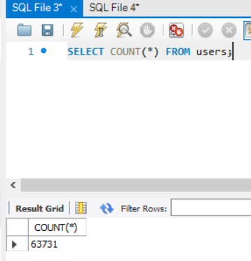

Figure 36 Number of rows in users table found by using SQL COUNT(*) function

Now we need to cross check this number with the csv file. This can be done by opening the file in Notepad, scrolling to the bottom of the file, selecting the last row and checking that the number matches. it should be noted that when viewing the number of rows in Notepad, Notepad will show 1 more row than MySQL. This is because the first row in Notepad is occupied by column names.

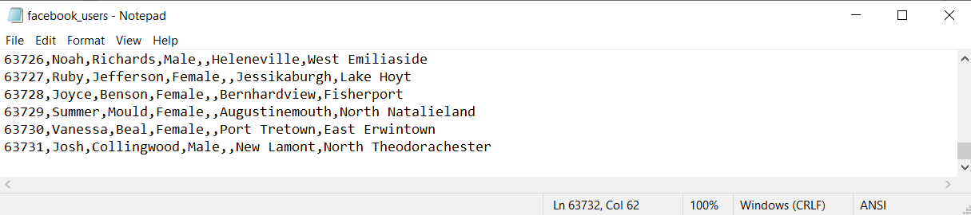

Figure 37 Cross checking number of rows with original csv file for users table

As expected, Notepad has 1 more row than MySQL, hence we know that all the user data has been imported.

The users table has 63731 entries.

This method will be repeated for the rest of the tables.

#### Friends data

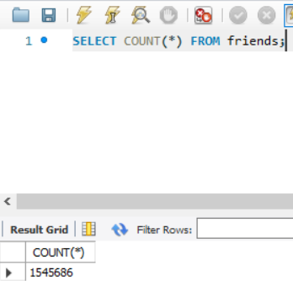

Figure 38 Number of rows in friends table found by using SQL COUNT(*) function

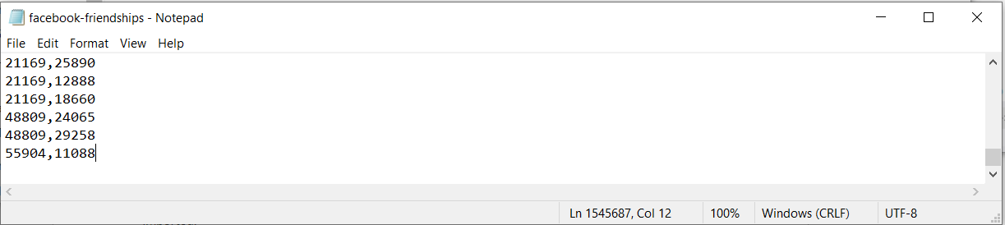

Figure 39 Cross checking number of rows with original csv file for friends table

The friends table has successfully imported 1545686 entries.

#### Universities data

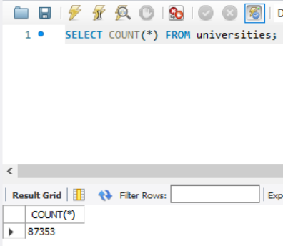

Figure 40 Number of rows in universities table found by using SQL COUNT(*) function

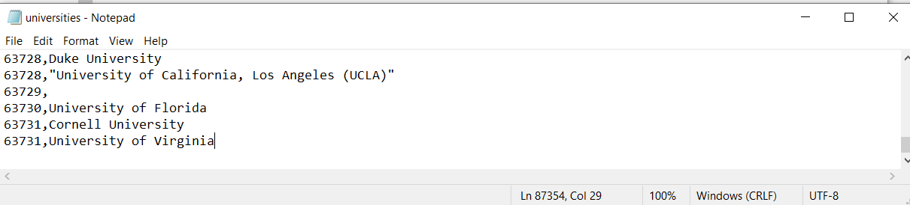

Figure 41 Cross checking number of rows with original csv file for universities table

The universities table has successfully imported 87353 entries.

#### Workplaces data

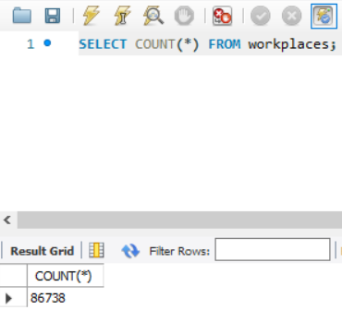

Figure 42 Number of rows in workplaces table found by using SQL COUNT(*) function

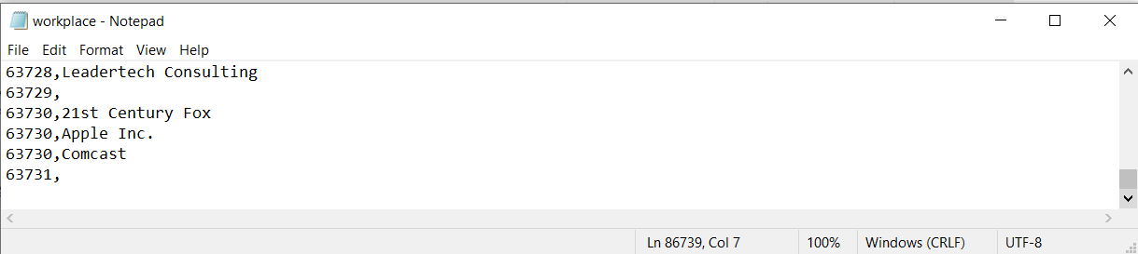

Figure 43 Cross checking number of rows with original csv file for workplaces table

The workplaces table has successfully imported 86738 entries.

#### Messages data

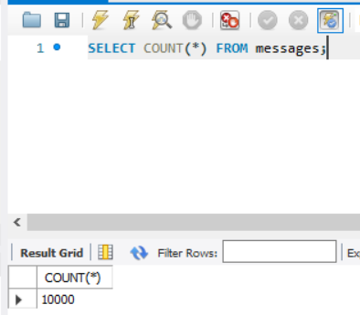

Figure 44 Number of rows in messages table found by using SQL COUNT(*) function

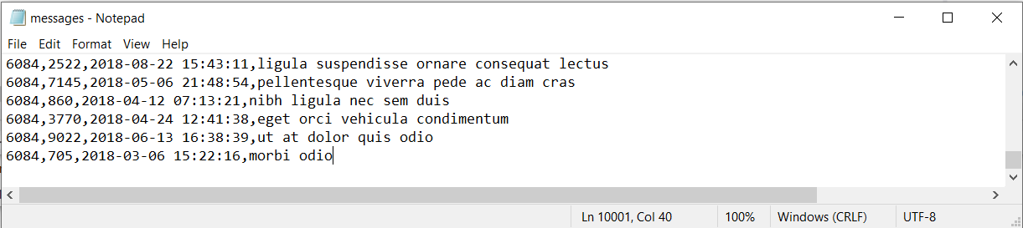

Figure 45 Cross checking number of rows with original csv file for messages table

The messages table has successfully imported 10000 entries.

Hence, with the INSERT INTO statements, the data import from the raw, csv file into the database with MySQL Workbench was successful.

## C# Interface

## Users form

#### Validation of data entry into the Users form

An essential part of executing the CRUD cycle is ensuring that the user enters the correct type of data into the fields available. Most of the fields on the Users form can accept any type of data in varchar form. The fields which need closer inspection and validation are:

* Query combo box

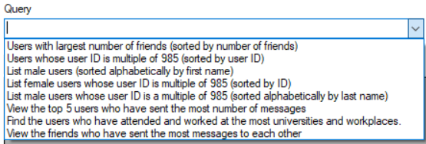

Figure 46 Specific queries available to database user

As seen, the query box will provide specific queries rather than letting the user enter their own queries. This eliminates any errors that might arise from typos. Each query is linked to a specific SQL query and hence preventing typos is key.

* User ID text box  
  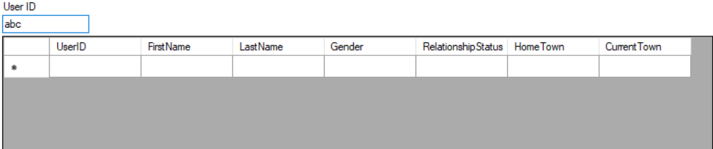

Figure 47 Text box not accepting non-integer entries

The User ID text box only accepts integer entries. Hence, if the user enters any value that is not an integer or an integer which doesn’t exist within the UserID column, the table will show up empty.

* Gender combo box  
  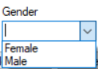

Figure 48 Gender data validation through providing a drop-down list instead of manual entry

The gender combo box ensures that the user only enters the gender which the database takes. This allows for consistent data to be entered and prevents any anomalies in the gender column

* Relationship status combo box   
  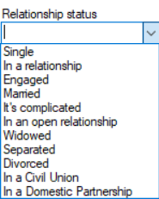

Figure 49 Relationship status data validation through providing a drop-down list instead of manual entry

Just like the gender combo box, the relationship status combo box ensures that there is consistent data being entered, preventing any data anomalies.

### Verify that create works

We will create a user with the following information:

First name: testfirst

Last name: testlast

Gender: Female

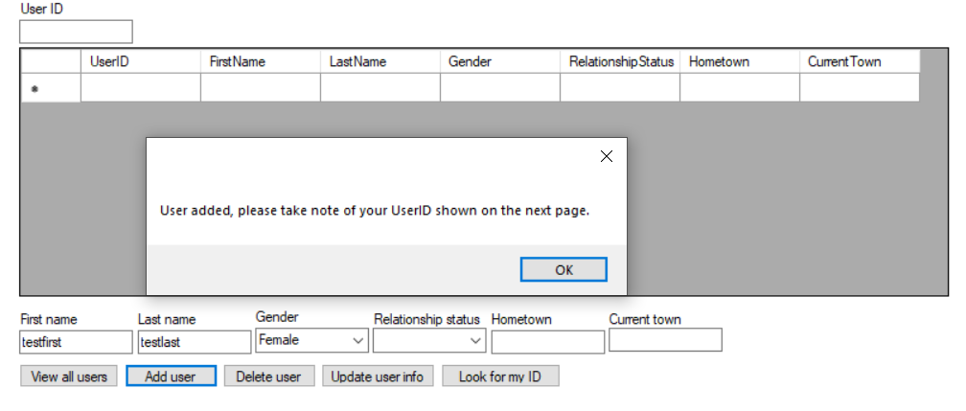

Figure 50 Message box pop up when a user has successfully been added to database

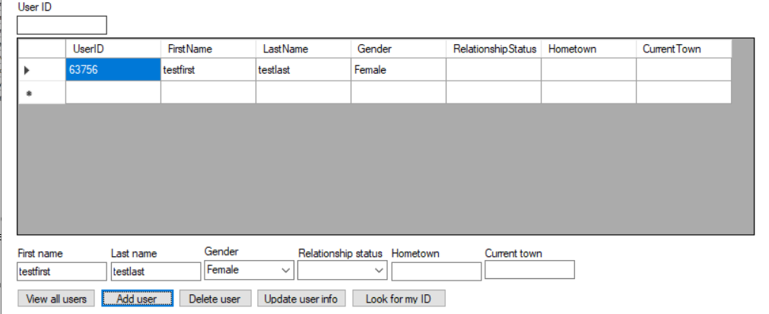

Figure 51 Table displaying user info for new user which was added

Now we see the UserID that is auto assigned to the new user we have created. In order to verify that our user has been added, we go back into MySQL Workbench and run the query “SELECT * FROM fb.users ORDER BY UserID DESC” to access the users table and sort it in descending order so that the most recent user created will show up at the top.

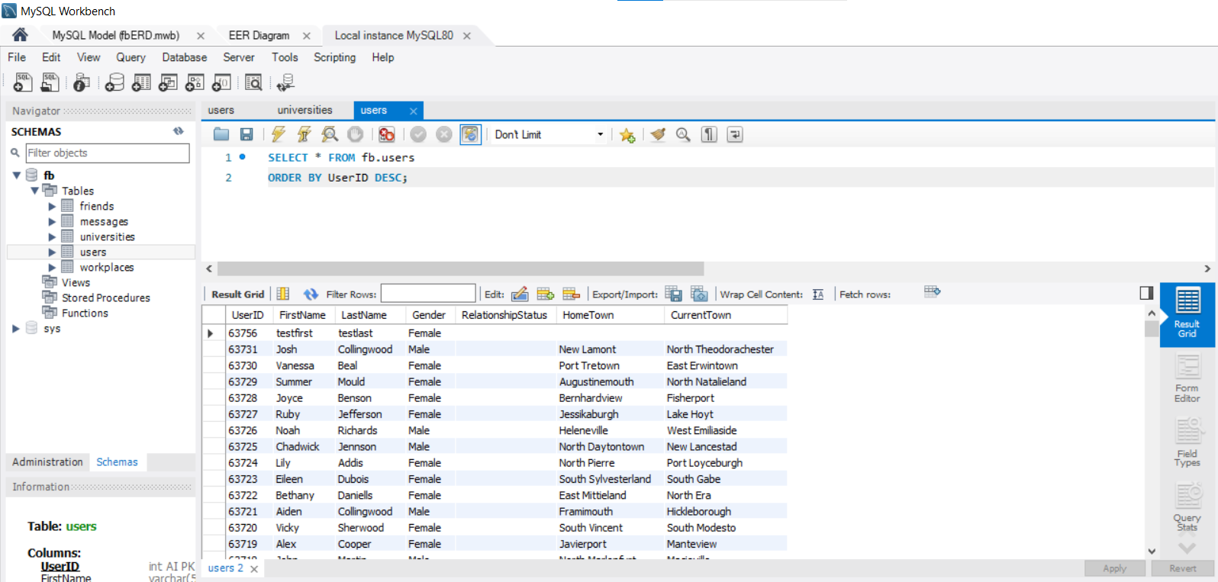

Figure 52 Verifying that added user shows up in database by cross checking with MySQL Workbench data

If we cross check this information with what we saw, we see that the information matches.

### Verify that read works

#### View all users button



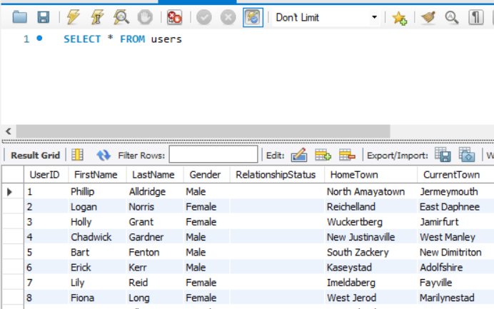

Figure 53 Verification of "View all users" button

To verify that the view all users button works, we cross check the result from pressing the button on the user interface with the result that we get on MySQL Workbench with query “SELECT * FROM users”.

When these two are cross checked, we see that the result is indeed the same, and therefore we have successfully verified the result.

#### Combo box

Verification of the combo box queries has been talked about in the C# interface section describing the combo box. Hence, I will not repeat it here.

#### UserID text box

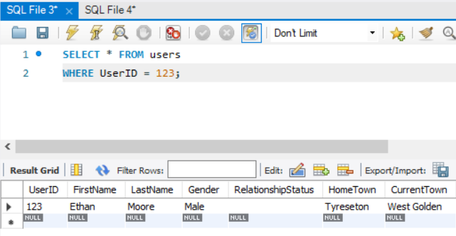

Figure 54 Verification of User ID textbox for reading

To verify that the User ID box works, I will use the example of User ID 123. To cross check, we enter the SQL query “SELECT * FROM users WHERE UserID = 123;”. When we run, we can see that the result returned is the same.

#### Look for my ID button

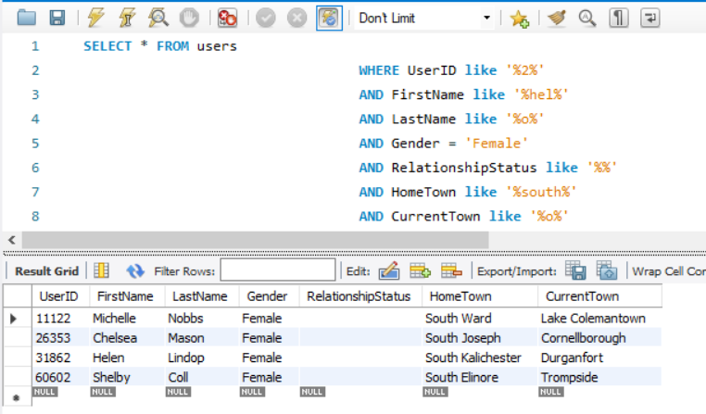

Figure 55 Verification of "Look for my ID" button

To verify the “Look for my ID” button, we will use the example where the entries are “UserID”: “2”, “FirstName”: “hel”, “LastName”: “o”, “Gender”: “Female”, “RelationshipStatus”: “”, “Hometown”: “south”, and “CurrentTown”: “o”.

The SQL query used for this is:

“SELECT * FROM users   
WHERE UserID like “%2%”   
AND FirstName like “%hel%”  
AND LastName like '%o%'   
AND Gender = 'Female'  
AND RelationshipStatus like '%%'  
AND HomeTown like '%south%'  
AND CurrentTown like '%o%'

When we cross check the result that we get from the user interface and the result from running the SQL query, we can verify that the interface is working correctly.

### Verify that update works

Let’s assume that our user got married, changed their last name and entered their hometown and current town to the following:

Last name: testlastnew

Relationship status: Married

Hometown: Singapore

Current town: Toronto

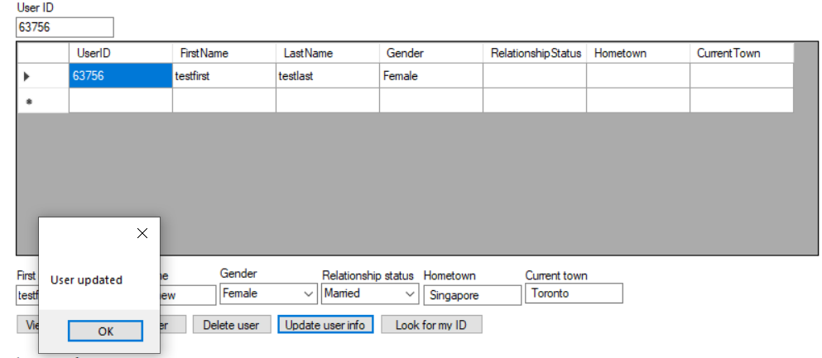

Figure 56 Message box pop up upon successful updating of User 63756 info

Then, the table will show us the user information that has been updated.

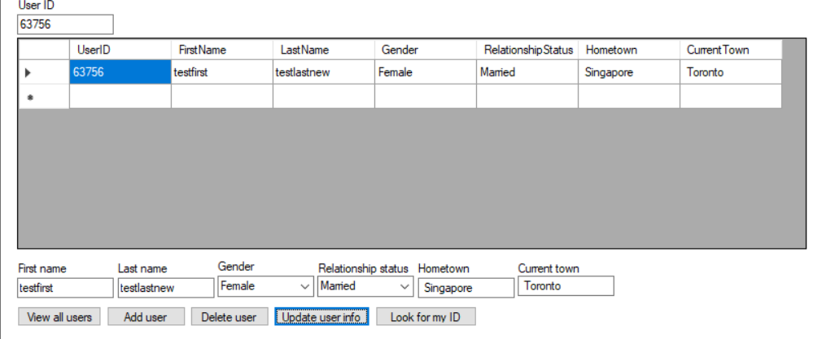

Figure 57 Table displaying updated user info

Again, we cross check this with the data that is in the users table in MySQL Workbench

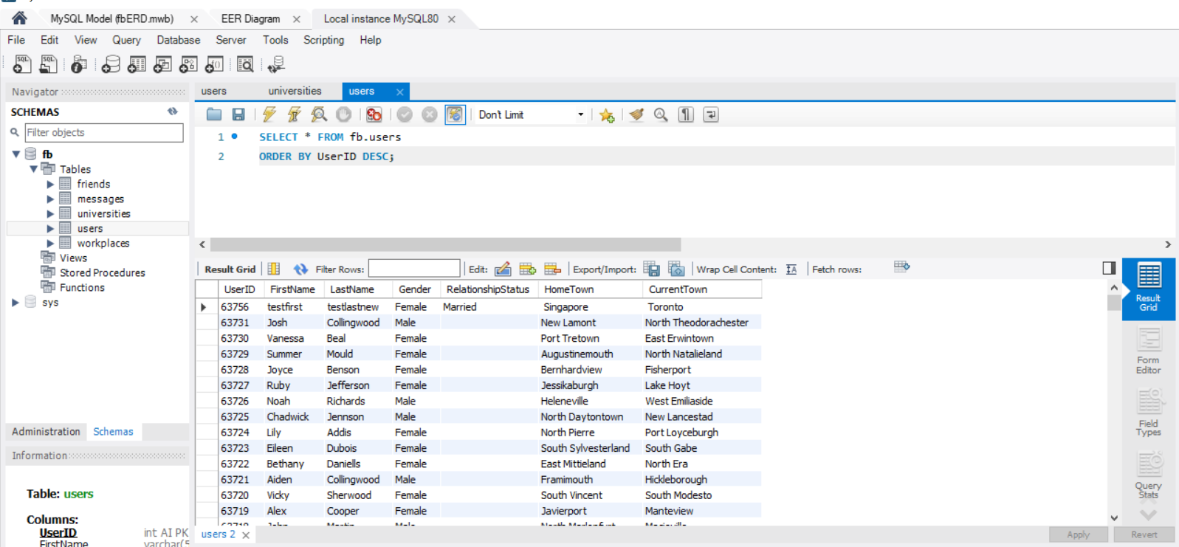

Figure 58 Verifying that update works by cross checking with MySQL Workbench

It can be seen that the information matches, therefore the update button works.

### Verify that delete works

Now, let’s delete the user that we have created by entering their UserID into the User ID textbox and clicking on the “Delete user” button.

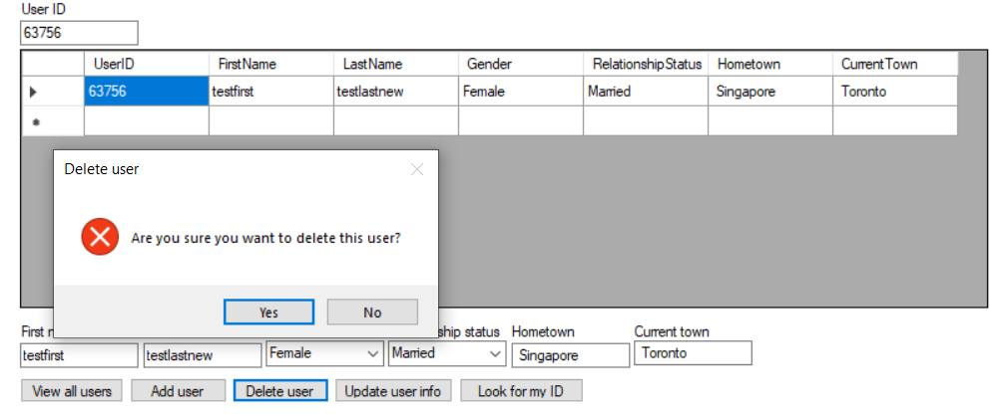

Figure 59 Warning box pop up to confirm deletion of User 63756

We see that a pop up box shows up and we click yes to confirm the deletion. Once done, the form lets us know that the user has been deleted.

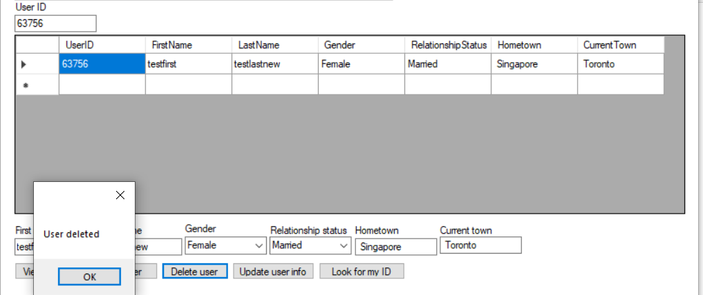

Figure 60 Message box pop up upon successful deletion of User 63756

Then we see an empty table indicating that the user has been deleted.

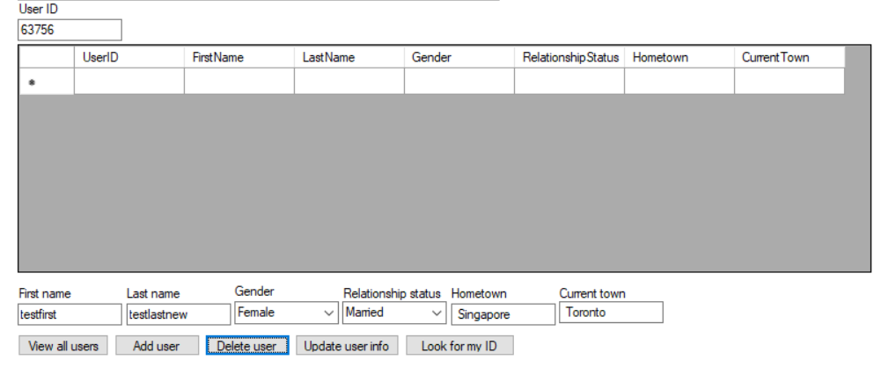

Figure 61 Empty table indicating successful deletion of User

Now, we cross check and verify that the user is no longer in the database. In MySQL workbench, the same SQL query is run and the user is no longer there.

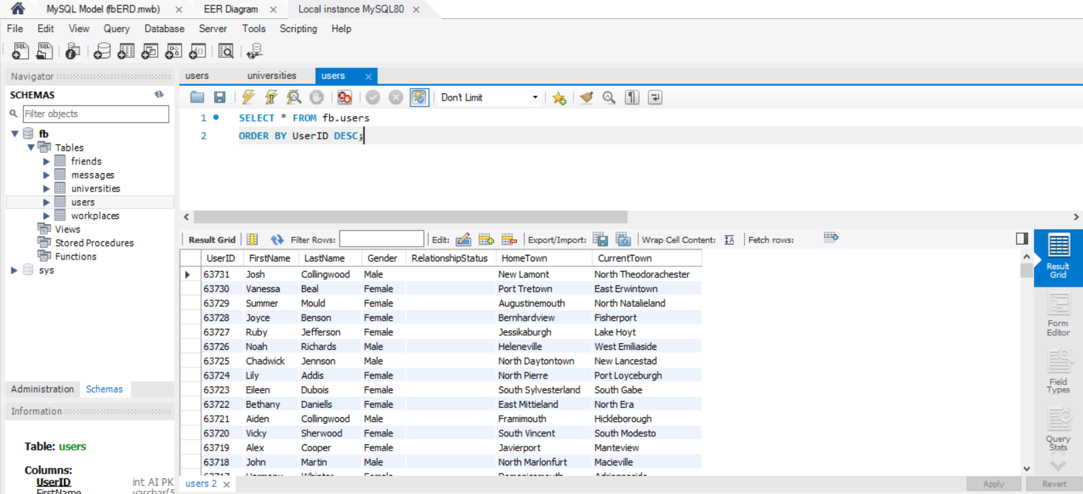

Figure 62 Verifying that delete works by cross checking with MySQL Workbench

If “no” is selected instead of “yes”, the user will remain in the database

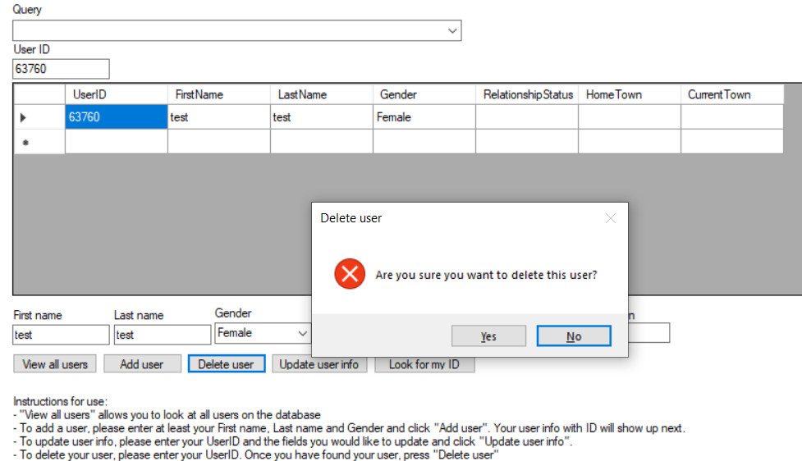

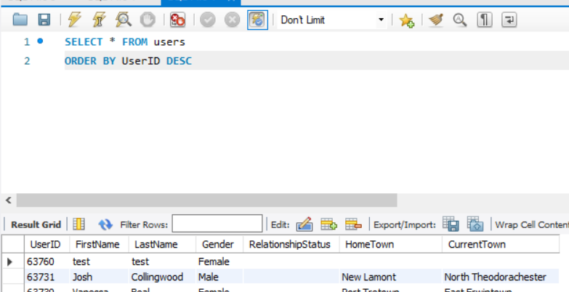

Figure 63 Selecting no and verifying that user remains in the database

We have verified that the user stays in the database above.

# Conclusion

## Areas for Improvement in Future Projects

### Normalization

Although there has been normalization to 3rd normal form and data validation through the use of drop-down lists for gender and relationship status, there can be farther improvement in these areas especially if there will be many queries on the database. For example, if the data set is even larger, it might be ideal to create a new table for Relationship Status where there are indexes assigned to each relationship status. This way, most of this data can be stored in the form of integers which take up less space than varchar. For the Gender table, another possibility is to store the different genders as a char(1) instead of varchar – i.e. “M” and “F” instead of “Male” and “Female”. These will not only free up space but also make queries involving gender or relationship status faster and allow for farther data validation.

It is possible to apply this idea across most of the fields in the users table; however, the more tables that the main table is split into, the more joins will need to be done and hence there will be longer query times because of these joins. Hence, there has to be farther evaluation into which method is more efficient in terms of the length of time it takes to run a query and how much space this will save.

### User Credentials

Currently, the user interface on C# works perfectly for the credentials where the username is “soft562_Cass” and password is “123Cass”. However, this user has been given the rights by the database admin to perform the entire CRUD cycle on the database. The user interface has not been created to account for users with credentials that might not allow them to perform the CRUD cycle. Hence, this is another area of improvement to consider in the future.

### Messages and Uninwork forms

As mentioned before, the “Messages” and “Uninwork” form are both read only. In the future, it would be good to allow the database user to perform the CRUD cycle on these two tables as well.

# References

“C# Program Structure And Basic Syntax With Examples.” *Software Testing Help*, 18 Jan. 2021, www.softwaretestinghelp.com/c-sharp/csharp-program-structure-and-syntax/.

Celko, Joe. “Normalization.” *Joe Celko's SQL for Smarties (Fourth Edition)*, Morgan Kaufmann, 28 Oct. 2010, www.sciencedirect.com/science/article/pii/B9780123820228000090.

Packer, Dan. “Verification vs Validation: Do You Know the Difference?” *Plutora*, 24 Nov. 2020, www.plutora.com/blog/verification-vs-validation.

Prateek T L. “Normalization in SQL: 1NF, 2NF, 3NF and BCNF in Database.” *Edureka*, 25 Nov. 2020, www.edureka.co/blog/normalization-in-sql/.

“SQL Join Types.” *SQL Joins Explained*, www.sql-join.com/sql-join-types.

STF. “Test Plan.” *SOFTWARE TESTING Fundamentals*, 18 Sept. 2020, softwaretestingfundamentals.com/test-plan/.

Wagner, Bill. “Access Modifiers - C# Programming Guide.” *Access Modifiers - C# Programming Guide | Microsoft Docs*, docs.microsoft.com/en-us/dotnet/csharp/programming-guide/classes-and-structs/access-modifiers.

Wang, Ming, and Russell K. Chan. “Database Development Process.” *Encyclopedia of Information Systems*, Elsevier, 28 Nov. 2004, www.sciencedirect.com/science/article/pii/B0122272404000265.

Willems, Karlijn. “SQL Tutorial: How To Write Better Querie.” *DataCamp Community*, 18 Jan. 2019, www.datacamp.com/community/tutorials/sql-tutorial-query.

# Appendix

Any additional data verification and validation for forms that were not requested in the assignment are placed in the appendix for farther reading.

## Login Screen Error Messages

Various error messages will pop up if requirements to open a new form are not met.

1. "Please enter a username and a password!"   
   Shown when the user has not entered both username or password  
   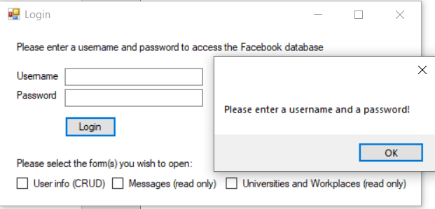

Figure 64 Message box pop up when user doesn't enter Username and Password

1. "Please enter a username!"   
   Shown when the user has not entered a username  
   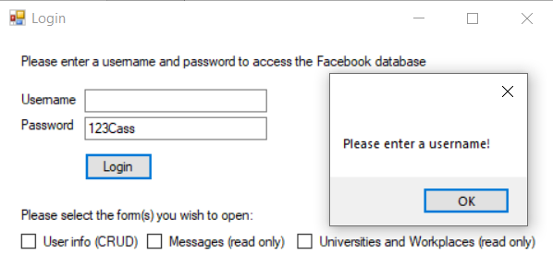

Figure 65 Message box pop up when user doesn't enter Username

1. "Please enter a password!"   
   Shown when the user has not entered a password  
   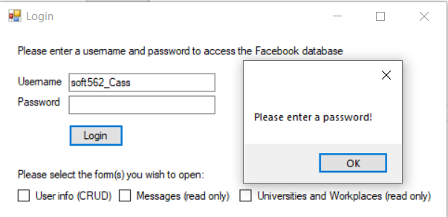

Figure 66 Message box pop up when user doesn't enter Password

1. "Invalid entry, please double check username and password"  
   Shown when the user has entered invalid credentials that will not allow them to access the database  
   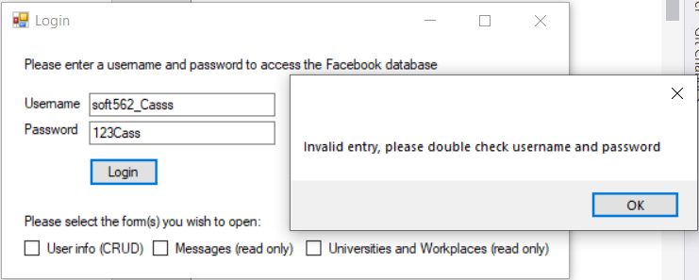

Figure 67 Message box pop up when user enters invalid Username or Password

1. "Please select a form to open!"  
   Shown when all credentials are entered correctly, however user has not selected a form to open.   
   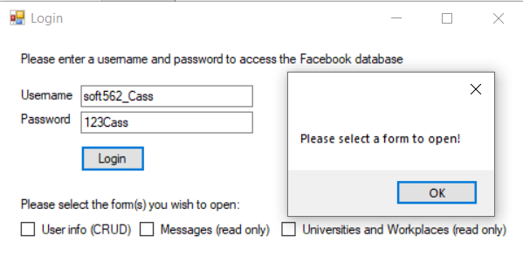

Figure 68 Message box pop up when user doesn't select any form to open

## Messages form

### Data validation

There are 3 areas in the form where data validation is required:

* Sender ID and Receiver ID textboxes  
  These textboxes are used to query the user ID, therefore they can only take integers. If a non-integer is entered in any of the boxes, there will not be any match with the User ID and the table will simply be blank. If the IDs which are entered also do not exist or there is no messages sent between the 2 IDs entered, then the table will also show up blank.
* Calendar date  
  The calendar tool which is provided by visual studio allows for consistency of the date being queried. Hence, we do not need to worry of the format that the user is entering the date in, and we only need to be concerned with the date which the calendar tool in visual studio returns when a date is selected.

## Uninwork form

### Data verification

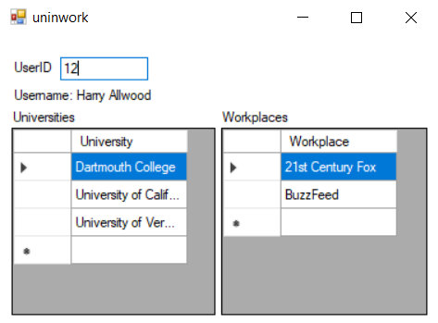

Figure 69 University and workplace details of User 12

As can be seen, by entering the UserID, the Universities and Workplaces that the user has worked at will appear in 2 separate tables. However, it should also be noted that the user’s name will also appear in the Username label. Within this simple form, I learned how to turn an SQL query into a string which will definitely be useful.

In order to verify that the information returned is correct, we go into MySQL Workbench and specific queries.

First, let’s check that UserID 12 is actually Harry Allwood:

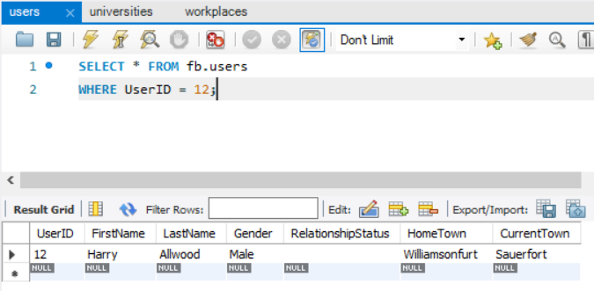

Figure 70 SQL Query to verify correct user name has been displayed

Great, we find that in the database, UserID 12 is indeed Harry Allwood. Now we run a similar query in both the universities and workplaces table

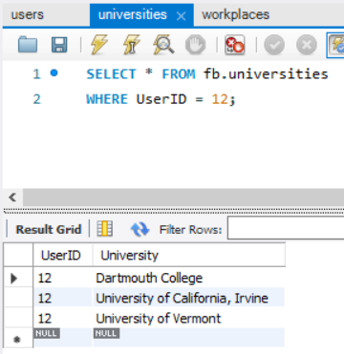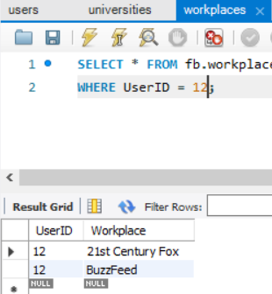

Figure 71 SQL Queries to verify correct user universities and workplaces have been displayed

With the 2 figures above, we see that the universities and workplaces returned in the tables in the uninwork form does in fact match the data within the database.

### Data validation

As the UserID textbox is used for querying the user’s user ID, it can only take entries that are integers. If entries are not integers, then the tables will simply be blank. Farther, if the entry which was entered does not exist within the database, the tables will also be blank.